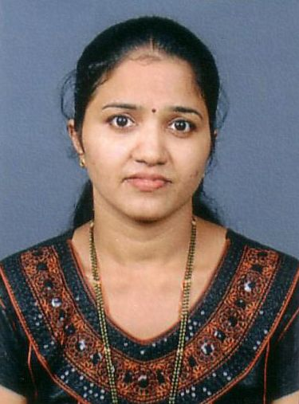

Curriculum Vitae

Mrs. SONALI

PERSONAL DETAILS:

Name: Mrs. Sonali

Date of Birth: 11th May 1982

Email ID: SONALI.375531@2freemail.com

CAREER OBJECTIVE:

- To become a good professional by imparting my professional abilities in the field of Library and Information Science / Information .
AREA OF INTEREST:
- Library Acquisition, Circulation, Classification, Cataloguing, Reference Services, Accessioning, Automation of Library, Searching of Journals, Articles, Books by use of Internet, Stock Verification and interest in Management of Library work etc.

EDUCATIONAL QUALIFICATION:

COURSE | INSTITUTION | % | YEAR
M.Lib | Indira Gandhi National Open university, Delhi. | 53% | March 2014
M.Com | Shivaji University,  Kolhapur. | 50% | Oct 2009
B.L.I.S. | Indira Gandhi National Open university, Delhi. | 59% | June 2008
B.Com. | Dyanprasarak Mandal’s,Assagao Goa. | 50% | April 2002
H.S.S.C. | Dyanprasarak Mandal’s,Assagao Goa. | 54% | April 1999
S.S.C. | St. Micheal Convent  High School, Anjuna Goa. | 48% | April 1997

WORK EXPERIENCE:

- Worked as a Librarian at NICMAR Engineering College Goa Mushtifund Saunstha from 1st July 2012 till November 2014.

- Worked as a Librarian at Shri Saraswati Mandir Public Library from 1st June 2010 to 31st May 2011 .

- Worked as a Librarian at IIAS School of Management, Goa Campus from 16th July 2005 to 31st May 2010.

LANGUAGE KNOWN:

- English, Hindi, Konkani, Marathi

NATIONAL CONFERENCE:

- Participated in workshop of ‘e-Granthalaya Software for Automation and Networking of Libraries’.
RESEARCH WORK:
Dissertation Submitted for the Master Degree in Library and Information Science (MLIS)

- QUALITY MANAGEMENT OF LIBRARIES AND INFORMATION CENTRES A CASE STUDY OF SOUTH GOA DISTRICT LIBRARY NAVELIM MARGAO GOA.

COMPUTER SKILL:

- Diploma in Computerised Accounting.

HOBBIES AND SPECIAL INTEREST:

- Reading Books, Listening to Music, Singing and Playing Games.

