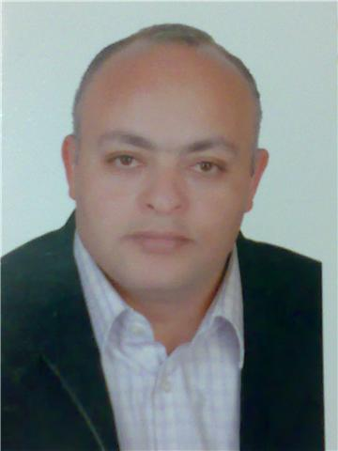

Dr.Deya

Aboali(Diagnostic Radiology specialist)

Mobile: Whatsapp +971504753686 / +919979971283
E-mail: Deya.375535@2freemail.com
I am a diagnostic radiology specialist, i have the master degree in diagnostic radiology and bachelor degree in medicine and surgery both from Cairo university in Egypt
I have a clinical practical experience in diagnostic radiology for over 15 years .

Education | -Bachelor degree in Medicine and Surgery MBBCh degree  { 6 years program study with Major / Specialization in Medicine and surgery } - Cairo University-Egypt | 12/1995
 | -Master degree of Diagnostic Radiology( 4 years program ):- Cairo University-Egypt  Thesis on :- MRI and CSF flow dynamics in evaluation of pediatric hydrocephalus ( CSF- Flowmetry). | 11/2002
- Membership of APCA physician – USA ( The Alliance for Physician Certification & Advancement ) .
- Membership of the American Society of Diagnostic Medical Sonography (SDMS) – USA .
-Registered Vascular Technologist (RVT), the American Registry for Diagnostic Medical Sonography (ARDMS):- from USA in 2008.
-A USA experience as a RVT and attendance of the vascular technology courses in NJ- USA .
-Attendance of :- Physician of vascular interpretation course in Chicago-IL USA .
-I am a registered licensed Radiology specialist (from the HAAD – UAE ). ( HAAD certified Diagnostic Radiology specialist )
–Eligibility of DHA ( Dubai health Authority ) eligibility letter .
-MOH –Emirates eligibility letter.

Professional Experience. | -Working in Al-Ahlia hospital in AbuDhabi -UAE – from 12 /2014 till 01/07/2016 .  -Working in Al-Badr hospital – from 01 / 04 /2012.  -Worked in Oman ministry of health ( Sohar hospital ) from 07/ 2010 till  March 2012.
*The organization of teaching hospitals and institutes in Cairo-Egypt: - (governmental teaching hospitals):- from 09/1998 .
*as an ass.specialist radiologist in:
- Al-Sahel teaching hospital (Egypt).
- Al-Matareya teaching hospital (Egypt).
-The National institute of Nephrology and urology(Egypt).
- Banha teaching hospital (Egypt).
-Egyptian Army forces hospitals: - from 70/01/1997-09/01/1998.
-Al-Tahra radiology centre in cairo, Egypt: - 04/01/2002 - 08/07 2003. (Private diagnostic radiology centre).
Cairo university hospitals: - (governmental educational university hospitals) as a resident in the diagnostic radiology department from 08/1999 – 07/2000.
-Cairo university hospitals: - (governmental educational university hospitals), intern from 03/1996 – 03/1997.
Performing and reporting different radiological examinations :-
*Color duplex ultrasound on upper and lower extremity vessels: including arterial and venous studies,including cases of DVT , varicose veins study and mapping , ultrasound guided compression for cases of Pseudoaneurysms following femoral angiography, hemodialysis shunt evaluation .
* carotid and vertebral arteries color duplex study, penile color duplex arterial and venous study for cases of male impotence, renal arteries duplex for suspected cases of renal artery stenosis , renal vein study for suspected cases of renal vein occlusion, color duplex of the Aorta and mesenteric vessels , color duplex of the portal vein and hepatic veins .
*Abdominal and pelvic ultrasound:- examinations for Liver , Gall bladder , spleen , both kidneys , pancreas ,intestinal masses, abdominal vessels , ascites and pleural effusion, urinary bladder, prostate and seminal vesicles.
* Pleural effusion , ascites :- measure volume and characters and performing ultrasound guided Aspiration.
*Gynecology and obstertric ultrasound: including transvaginal ultrasonography, fetal biophysical profile, umbilical artery flow.
*Transrectal ultrasound: for the prostate, seminal vesicles and the terminal vas differens.
*Transcranial ultrasound and color duplex USG on the cerebral vessels .
*Small parts ultrasound:- for the Thyroid gland , Breast and Axillary ultrasound , Salivary glands , Lymphadenopathy , soft tissue mass lesions evaluation ( power duplex).
*Hip ultrasound for cases of DDH (CDH) of the hip joint and other MSK examinations.
*Scrotal ultrasound and color duplex: - for varicocele detection and grading, scrotal and testicular abnormalities.
*3D &4D ultrasound .
* ultrasound and C.T guided biopsy and aspiration.
* Different Conventional , contrast radiological Techniques, Barium and water soluble contrast studies, perianal fistulas , T.tube cholangiography , ...... .
*Computed tomography reporting of different regular cases, including CT Angiography on the Aorta, extremities , renal arteries, carotids and cerebral vessels .
* MRI studies reporting .

 | (These includes regular and emergency cases studies ,hands on practical scanning )
Computer Skills | Microsoft word, power point presentations and Internet, PACS/RIS computer systems .
Language | Arabic |  | Excellent (Mother tongue)
 | English |  | Excellent.

