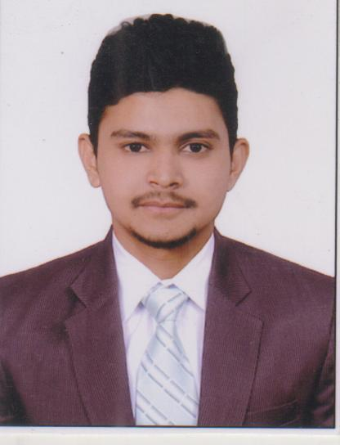
AZHER
EMAIL: azher.375537@2freemail.com
ADDRESS: DUBAI, UAE
VISA STATUS: VISIT VISA.

_______________________________________________________________________________________
CAREER OBJECTIVE:

Looking for a challenging role where I can use my capabilities and to be involved in a greater challenge where there is a high level of learning involved and which make the best use of skills and abilities for the successful growth.
_______________________________________________________________________________________
Academics:
- Bachelors of Technology, (Civil Engineering).
Jawaharlal Nehru Technological University, Hyderabad.

Experience
Work as a Site Quantity Surveyor in “THE ENGINEER’S CONSULTANCY”HYDERABAD from June 2016 to November 2017.

Duties and Responsibilities:
- Supervision of the site work as per the drawing.
- Regular Site visit for progress follow up.
- Maintain daily and weekly work records and reported to the higher officials.
- To determine strength and adequacy of foundation, concrete by testing soil material.
- Execute steel as per approved structural drawing.
- To ensure the quality of product using construction.
- Maintaining quality standards for all structural works
- Preparation of Detailed Estimates.
- Studied about the estimation of BBS (Bar Bending Schedule).
- Preparing escalation bill for the materials.
- Estimate concrete to be poured on site.
- Monitoring the installation of foundation.
- Prepare invoice/ valuation/ bill for the work done by every month.
- Prepare report on what has been studied, and submit the results to the head of the department.

AREA OF EXPERTISE:
Auto Cad 2016.
- Preparation of plans, Elevation and Sections.
- Typical floors, Kitchen, Toilets etc. Sections, Detailed Drawings.
- Taking measurement and shop drawings for submission.
- All types of shop drawings (Staircase, Block work, Tiling, Flooring etc.)
- Transferring Auto Cad Drawing to PDF, JPEG etc.

Quantity Surveying:
- Preparation of complete BOQ as per tender drawing.
- Estimates concrete to be poured on – sites.
- Preparation of Detailed estimates.
- Preparation of Bar Bending Schedule and BOQ.
- Quantity take off for architectural and structural material based from construction drawings.
- Calculate the Quantity using Auto Cad and by manually.
- Quantity takeoff for sub structure and super structure using Excel and Auto Cad.
- Preparation of invoice/ valuation / Bill.
- Estimates the BOQ by using SSR (Standard Schedule Rates) at 100% accuracy.
- Performed detailed calculation to establish manufacturing, construction and installation standard and specification maintaining 100% accuracy rate.

Staad Pro :
- Design and Detailing of Multi –Storied buildings.
- Design of Slab, Footing, Staircase by Manually.
- Detailing of Beams and grouping of Columns.

Academic PROJECTS:
- Project 1:
- Title : Types of Foundation
- Description : This Project deals with the basics of types of foundation, its classification, importance and selection of different types of foundations accordance to situational things.

- Project 2:
- Title : Analysis and Design of Multi – Storied Building.
- Description : This project help us to analyze and design a structural system for an illustrative multi – storied building by using Staad Pro and Auto Cad.

Software PROFICIENCY:
- Auto Cad 2016 – from Build a World Technology, Nizamabad.
- Microsoft Word, Excel and PowerPoint.
- Staad Pro – from SWO Job Oriented Training Institute, Hyderabad.

Courses undertaken:
- Quantity Surveying – from THE ACADEMY OF QUANTITY SURVEYORS, Hyderabad.

Achievements:
- Actively participated in various events during schooling like Drawing, Seminar Presentation.
- Actively participated in various sports during schooling like Football, Cricket etc.
- Won prizes in games and extracurricular activities.

Strengths:
- Have overall experience of 2 years in Site Quantity Surveyor.
- Adjusting to new environment very quickly.
- Good time management skills.
- Experience of working in group task.

Personal Details:
- Visa Status : Visit Visa Valid Till 1st March 2018.
- Date of Birth : 18.04.1994.
- Nationality : Indian.
- Marital Status : Single.
- Languages Known : English, Hindi and Urdu.
- Place of Issue : Hyderabad, India.

Declaration:
I declare that the information and facts stated here in are true and correct to the best of my knowledge and belief.

(AZHER)

