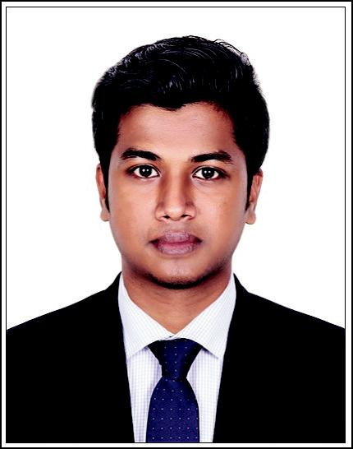
NIJIN
Al Nahda, Dubai

Email : nijin.375562@2freemail.com

CAREER OBJECTIVES

Eager to work in a challenging and competitive environment where I can contribute and expand my technical knowledge and soft skills.

SKILLS

Auto CAD 2D, Electrical CAD, Revit MEP

Programming Languages known: C, C++

Package: Microsoft Office, Adobe Photo shop.

Interested in taking responsibilities and sincere in working.

Easily finds and maintain healthy friendship with any group and likes to be a team player and a match winner.

ACADEMIC PROFILE

Course | College/School | University/Board | Year of
 |  |  | Passing
B Tech, | Mohandas College of
Electrical and | Engineering and Technology, | Kerala University | 2016
Electronics | Anad
Engineering
12th Standard | ST.Shanthal Eng Med School | CBSE | 2012
 | Kodunganoor Trivandrum
10th Standard | ST.Shanthal Eng Med School | CBSE | 2010
 | Kodunganoor Trivandrum

WORK EXPERIENCE

Sagar Realtors Pvt Ltd.

Lead Electrical Supervisor

2016 Sept to 2017 Sept

Position held
Supervisor In-charge Electrical system installation,repair and maintenance

SEMINAR PAPERS PRESENTED

Scalable DC Micro grid

ACADEMIC MAIN PROJECT

Coupled Inductor Based Single input Multiple Output DC - DC Converter

PERSONAL PROFILE

Age and DOB | : | 23, 08 Jul 1994
Gender | : | Male
Nationality | : | Indian
Languages Known | : | English, Hindi & Malayalam
Hobbies & Interest | : | Playing Cricket, Listening to Music, Computer Gaming,
 |  | Traveling & Cooking

DECLARATION

I hereby declare that the information/statements furnished above are true to the best of my knowledge and belief and none of them are false.

Nijin

