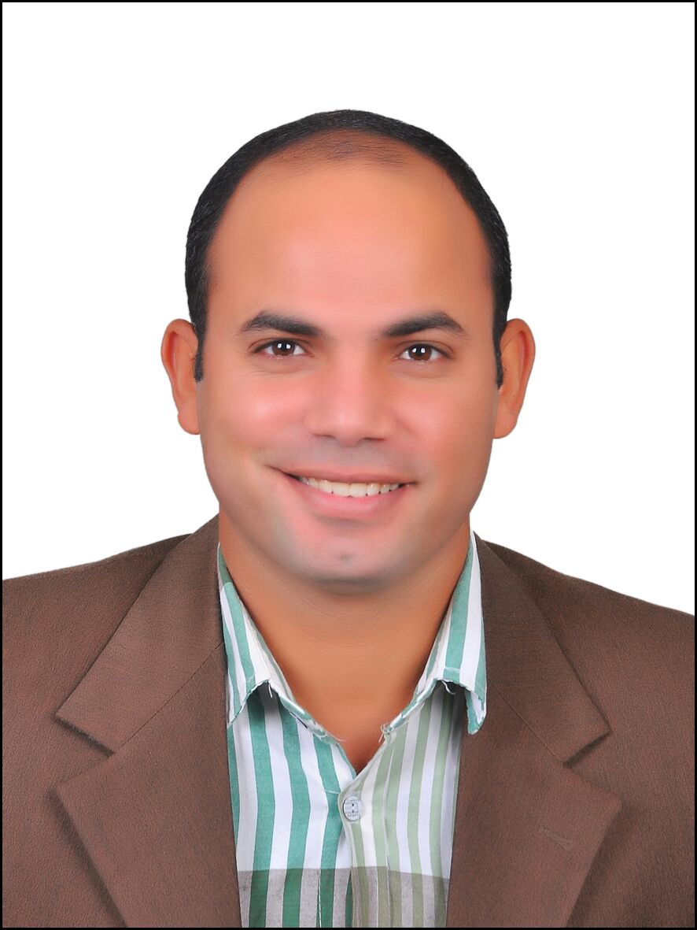
Ibrahim
Ibrahim.375570@2freemail.com
Personal Information:
- Date of Birth : 1st September 1988.
- Nationality : Egyptian.
- Address : Elbarsha behind Emirates Mall, Dubai.
- Marital status : Married.
Objective:
I am seeking for a Job Opportunity at your Company; to enhance my personal skills, increase my technical knowledge, and gain more experience. This is will be a step for more development in surveying in the world.
Education:
- Bachelor’s degree from Suez University, Faculty of Petroleum and Mining Engineering in 2013.
- (Grade: Good); (Degree: 73.48 %). 2nd rank at mining engineering department.

Graduation Project:

1- Surveying project:
Grade: Excellent.
.
Career:

Surveying Engineer
Course:

- I have got courses in surveying and various devices including ;total Station, level and some programs as: Civil 3D , AutoCAD , sokkia link , prolink

Experience:

- (2017; 2016)Surveying Engineer at Hassan Allam Company for contracting
- 2015; survey engineer at eltaqwa company.
- 2013; Surveying Courses in Suez, and Mansoura Universities.
- 2012; Summer Training in Ceramica Cleopatra factory.
- 2011; Summer Training in Alsukari.
- 2011; Summer Training in Abu Tartour phosphate mine.
- 2010; summer training in Sina Manganese company.
- Worked at sand and gravel quarries.
- I have got training in consulting engineering surveying company.
Languages:
- Arabic: Native.
- English: Very Good.

Communication Skills:
- Able to work under pressure.
- Able to work in a Team Work.
- Able to learn independently.

Computer Skills:
- Advanced in Microsoft Office: Word, Power Point and Excel.
- I can deal with surveying and mining programs easily.
- Basics of mining software with surpac and other programing like surfer and AutoCAD.

