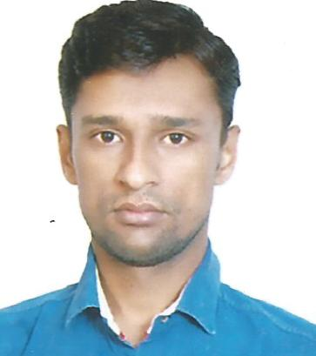

PANKAJKUMAR
E-mail: PANKAJKUMAR.375579@2freemail.com

aPPLICATION FOR THE POST OF: ANY SUITABLE POST

objective
I would like to share my experience for the organization with all my capabilities skills, knowledge. Also would like to become a team member for the growth of the organization
Work Experience

- Worked as a Sales Executive at Smart Choice, Mumbai, India, for 3 Years.
- Worked as a Sales Man at Jinendra Mobile John, Mumbai, India, for 3 Years.
- Worked as a Sales Man at D Mart at Gujarat, India, for 1 Year.
- Worked as a Office Boy (All Over Office Work) at Leena Décor, Mumbai, India, for 2 Years.
- Worked as a General Helper at Jain Sons, Mumbai, India, for 1 Year.
key skills

- Administrative and computer skills
- Team work ability
- Leadership and communication skills
- Research and analytical skills
- Well Experience above mentioned field
- Self-Confident sincerity Hard Work and Punctuality
- Honest and dedicated Person
EDUCATIONAL QUALIFICATION
- Graduation (B.A)
passport details
Date of Issue : 04/08/2010
Date of Expiry : 03/08/2020
Place of issue : Ahmedabad, India
Personal Details
Date of Birth : 12/03/1985
Nationality : Indian
Religion : Hindu
Gender : Male
Marital Status : Married
Language Known : English, Gujarati & Hindi
Visa Status : 3 Months Visit Visa
declaration
- I certify that all the details provided above are all correct according to my knowledge and belief.

