CURRICULUM VITAE
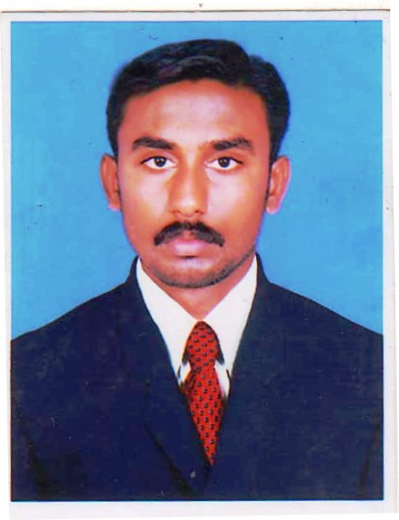

SIVARAMAN
ELECTRICAL ENGINEER
E-mail : SIVARAMAN.375596@2freemail.com

Visa Status : Visit visa valid up to 10th February 2018

Career Objective:

Looking forward to work in a well known company where I can use my skills and abilities through challenges, dedication and growth- oriented activities.

EXPERIENCE DETAILS : (2 Years in UAE +8 Years in India )

SRS ELECTRICALS AND CONTRACTOR

Duration : Nov 2014 To Nov 2017
Job Position : Electrical Engineer
Place : India-Tamilnadu
Responsibilities:

- Study of drawings and execute the work.
- Preparation of Load schedule and Estimation from Drawings.
- Installation of all type Electrical Equipment’s, DB’s, SMDB’s and LV panels.
- Site Supervision of Works and time schedule follow up.
- Cable size calculation scheduling and cable route selection.
- Material Requisition and Material purchasing work etc...
- Attend the site technical coordination and site safety coordination meeting.
- Preparation of Project Report and Timely information for the Progress of work.
- Final Documentation & Billing Works.

EMIRATES CANADIAN CONT.CO. L.L.C

Duration : Feb 2013 To Oct 2014
Job Position : Electrical Engineer
Place : Dubai-UAE
Responsibilities:

- Follow up the all electrical department work in the project.
- Designing, planning and scheduling new electrical works in the project.
- Prepare the load schedules.
- Preparing all submittals for the drawings and materials to the consultant and following up for the approvals.
- Prepare IR, MIR and interim payment to the consultant and following up for the approvals.
- Clarification of any deviation from the drawing and discussing the issue with the consultant
- Worked with the specification, standards and relevant local authority regulation and requirements.
- Preparation of shop drawings with coordination of MEP.
- Preparation of all electrical materials take off, requisitions and control.
- Preparation of bill of quantities for complete electrical systems from drawings.
- Prepare all the electrical as built drawings for submitting to consultant and client.
- Coordinate with consultant for the work progress and manage the work as per schedule.
- Follow up the testing and commissioning of all electrical systems handling to client.

SRI MARUTI WIND PARK DEVELOPERS
Duration : Oct 2010 To Jan 2013
Job Position : Electrical Engineer
Place : India – Maharashtra (Satara)
Project Details:
132/33KV (220MW) SUBSTATION (vaspet)
Client : Global Wind Power Pvt Ltd
Project Details:
2.5MW & 1.5 MW Wind Machine.
Client : Global Wind Power Pvt Ltd, Regen Power Tech.
Responsibilities:

- 33KV VCB Switch Yard Erection Work.
- Preparation of material requisitions for switch yard structure materials and electrical equipment such as CT & PT ,VCB, Transformers ,Cables etc…
- 33KV Over Head Line Erection and material preparation work.
- Co-ordination with Client and Consultant.
- Supervision of Works and time schedule follow up.
- 132/33KV Substation erection and 33/11KV Substation Bay work.

TAMILNADU ELECTRICITY BOARD
Duration : July-2009 To July 2010
Job Position : Graduate Apprentice Trainee
Place : India- Tamilnadu
Responsibilities:

- Maintenance of 110/11KV Substations.
- Preparation of Daily and monthly maintenance sheets and daily load, temperature readings.
- Testing of Distribution transformers and Transformers Oils.
- Maintenance of oil Reclamation plant.
- Testing of Single phase & 3 phase Meters Testing of LTCT and HTCT services.

MPM TEXTILES PRIVATE LIMITED

Duration : June 2008 To June 2009
Job Position : Asst. Electrical Engineer
Place : India – Tamilnadu
Responsibilities:
- Operation and Maintenance of 2000KVA Transformer and 500KVA Generator sets.
- Operation and Maintenance of control panels.
- Preparation of monthly maintenance schedule.
- Operation and Maintenance of all motors up to 60KW etc.

ACADEMIC BACKGROUND:
- B.E –Electrical and Electronics Engineering - 68%,
Sethu Institute of Technology - Anna University, Chennai.

- Diploma in Computer Technology – 80% ,
State Board of Technical Education Chennai.

- Hr.Sec – 70% -P.K.N.Hr Sec School, Thirumangalam.

- S.S.L.C – 80% -P.K.N.Hr Sec School, Thirumangalam.

Major Courses:

- Advanced Diploma in Computer Hardware Networking, Grade-A+, Government of India. Ministry of Small Scale Industries.

Computer Skills:
- Operating Systems : Windows 95, 98, XP, 2000 Professional
- Application Programs : MS Office etc..

PERSONAL INFORMATIONS:

Nationality : India
Date of birth : May 14, 1985
Marital status : Married
Blood group : B +
Language Known : English, Hindi, Tamil and Malayalam
Driving License : India

DECLARATION:

I hereby declare that the above furnished details are true to the best of my knowledge.

Yours truly,

