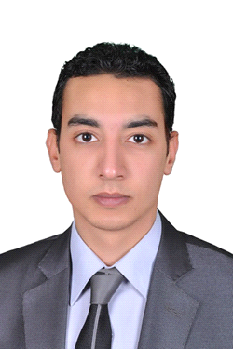
Yehia

Address : Egypt
Email : yehia.375602@2freemail.com

ـــــــــــــــــــــــــــــــــــــــــــــــــــــــــــــــــــــــــــــــــــــــــــــــــــــــــــــــــــــــــــــــــــــــــــــــــــــــــــــــــــــــــــــــــــــــــــــــــــــــــــــــــــــــــــــــــــــــــــــــــــــــــــــــــــــــــــــــــــ
Personal Data:
- Gender : Male
- Data of Birth : 24/12/1987
- Nationality : Egyptian
- Marital Status : Engaged
- Religion : Muslim

Education:

- Faculty : Faculty of Art Education- Zamalek
- University : Helwan University – Branch Zamalek
- Grade : Very Good
- Graduation year : 2011

Computer & Programs Skills:

- 3Ds Studio Max - Vray Autodesk Certified Professional 3ds Max 2014 -
( course at al-rebat for graphics )
- AutoCAD Very Good
- Photoshop Very Good
- Twinmotion Very Good
- Aftereffect Good
- ICDL

Languages Skills:

- Arabic : Mother tongue
- English : Good

Work Experience:
- 3d Artist for 5 years
- Interior and Exterior designer for 3 years at the engineering office for contracting
- Department Administrator Exterior design for 3 years in same contracting co.
- Supervisor of interior finishes in same contracting company for 1 year
- 3Ds Max instructor at Resala Society for 2 years
- advertising designer for 2 years in Kingdom of Saudi Arabia
Certificates:

- Autodesk Certified Professional 3ds Max 2014
- A Training certificate in the department of decoration in T.V in A.R.E.
- Certificate of Appreciation for participating in the Technical Workshop For the teaching of human rights.
- Quality Assurance Unit Appreciation Certificate from the faculty of arts of education.
- Excellence Certificate from the faculty of arts of education.
- Certificate of Appreciation for participating in Elsakia photography contest.
Technical workshops:

- Experimental workshop for Media and creativity 2008(Art Creation Interactive).
- Experimental workshop for Media and creativity 2009(Art Creation Interactive).
- Experimental workshop for Media and creativity 2010(Art Creation Interactive).
- Technical Workshop For the teaching of human rights2009.
- Experimental workshop for Quality Assurance Unit 2009.

Galleries:

- Gallery of plastic arts 2008.
- Gallery of Experimental workshop for Media and creativity 2009.
- Gallery of Experimental workshop for Media and creativity 2010.
- Gallery of Technical Workshop For human rights.
- Gallery of in Elsakia photography.
Personal Characteristics:

- Good appearance, Good Speaker, Ambitious, Active.
- Ability to learn new tasks quickly.
- Ability to work well with all levels of management personal.
- Demonstrated ability to work independently and as a comparative team worker.

