Curriculum vitae
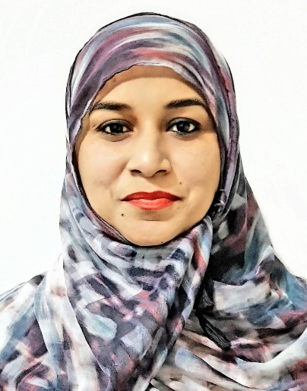
Arshiya
Objectives

To secure a position where my skills in the activities of Marketing, Sales, Customer Services, Administration and any such related field can be utilized by a progressive and innovative company. I have an experience of 9 years 5 months in sales Customer Service seeking next career move with an established business that is seeking further development and increased profits. I would like to obtain a job with long term prospects where by hard work, dedication and ability to acquire new skills will provide me the opportunity for growth based on performance and also advantage the company I work for.

Work Experience

Nature’s Gift Wellness Pvt. Ltd
Duration: 1st july 2014 till date
Designation: Brand Ambassador (Sales – Retention – UK Process)
Job profile: Target oriented, speaking to existing customers to retain and upsell the product over the Phone.
- Convincing them to buy our product (natural supplements for health problems)
- Achieving individual targets by default by the end of the month by keeping customer service in mind
- Handling inbound customer calls for any queries and smooth product delivery.
- Conducted briefings and maintained a Healthy, supportive and friendly atmosphere between the team.

NHC Tele Services Pvt. Ltd
Duration: 26th April 2013 to 30th Jun 2014
Designation: Brand Ambassador (Sales – Retention – UK Process)
Job profile: Target oriented, Building rapo with the customers over the phone by keeping customer service in mind
- Checking their health condition
- Convincing them to buy our product (natural supplements for health problems)
- Dispatching the goods
- Achieving individual targets by default by the end of the month
- Data entry
- Conducted briefings and maintained a Healthy, supportive and friendly atmosphere between the team.

Sanda Wellness Pvt. Ltd
Duration:1st Oct 2008 to 15th Oct 2011
Designation: Sales Manager (UK Process)
Job profile: Target oriented, handled a team of 20 sales executive.
- Achieving the team targets by default by the end of the month by keeping customer service in mind.
- Helping my team to achieve individual targets by default by the end of the month.
- Conducting briefings and motivating the team to obtain the given target.
- Sending daily sales report to Senior Sale Manger by end of the day.

Gold Shield Pvt. Ltd
Duration:21st May 2007 to 30th Sept 2008
Designation: Customer Relation Executive (Sales – Recruitment – UK Process)
Job profile: Target oriented, Building rapo with the customers over the phone
- Convincing them to buy our product (natural supplements for health problems)
- Achieving individual targets by default by the end of the month
- Maintained a Healthy, supportive and friendly atmosphere between the team.

Saple Infotech Pvt. Ltd
Duration:11th Nov 2006 to 11th May 2007
Designation: Customer Care Executive (Sales – US Process)
Job profile: Target oriented, Building rapo with the customers over the phone
- Convincing them to buy Phone with Connection
- Achieving individual targets by default by the end of the month
- Maintained a Healthy, supportive and friendly atmosphere between the team.

Educational Qualifications

- B.com from (MKU) Madurai Kamraj University, Goa. (2008).
- H.S.C (Commerce) from Delhi Board, Mangalore. (2003)
- S.S.C from Karnataka Board, Mangalore. (1999)

Computer Knowledge

- Excellent knowledge of computers.7
- Computer course in accounting with Tazlly

Personal information

Date of Birth : 20th Sept 1983
Nationality : Indian (Goa)

Marital Status : Married
Email id : arshiya.375605@2freemial.com
Languages Known : English / Hindi / Kannada
Declaration

I hereby state that above mentioned particulars are true to the best of my knowledge
and belief.

Place : DUBAI Signature

Date : __ /__ /____ (ARSHIYA)

