CURRICULUM VITAE

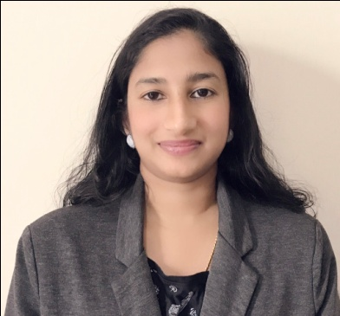
DIVYA

Email: divya.375623@2freemail.com
Career Objective

To become a successful professional and to work in an innovative and competitive environment as a contributing member with commitment & dedication where my educational & experience potential meets the needs of the industry.

Personal Skills

- Comprehensive problem solving abilities
- Verbal and written communication skill
- Ability to deal with the people in a diplomatic manner
Work Experience
- Worked as iphone Application Development Trainer in Srishti Innovative
Technopark Trivandrum (From April 2013 to June 2014)
- Worked as Guest Lecturer in Institute Of Human Resource Development Government Of Kerala
(From June 2011 to May 2012)

Technical Skills

- iPhone Application Development
- MS word, Powerpoint , Excel applications

Academic Qualifications

- iPhone Application Development : Srishti Innovative Computer Systems
Thejaswini Technopark Trivandrum from Jan 2013 to April 2013
- B Tech in Electronics and Communication : Mahatma Gandhi University, Kottayam from 2007 to 2010
- Diploma in Applied Electronics : Board of Technical Education, Govt. of Kerala .
from 2004 to 2007.

- Plus 2 , Indian School Certificate (ISC) from 2002 to 2004.

- SSLC : Board of Technical Education, Govt. of Kerala from 2001 t0 2002.

Project Details.

- GPS based BLACK BOX and Digital Dashboard for automobiles
In this embedded project based on microcontroller AT89C51; we upgraded the conventional dash board of automobiles with a smart, interactive digital dash board, made to display the speed, distance, amount of fuel, engine as well as cabin temperature, position and presence of nearby vehicles.The GPS made the design very attractive since we can see our position (latitude, longitude, inclination, speed etc). All the above parameters are recordable and can be used for future reference if vehicle encounters an accident.

- Biped Walking Robot with Wireless CAM and Zigbee
The aim of this project is to develop a two legged walking robot, that can be used for unmanned mission which collects various sensor parameters and transmit the collected data to the control station via wireless means. The robot detects obstacles in its path. The whole working of this project is based on PIC 16F877 micro controller and mechanical section. The micro controller stores the programme that controls movement of robot and senses other various parameters. The mechanical section consists of servo motors for the movement of robot.

Language Proficiency

- Highly Professional : English, Hindi, Malayalam

Personal Profile

- Sex : Female
- Marital Status : Married
- Nationality : Indian
- Visa Status : Husband Visa

- Hobbies : Cooking, New Technologies

Declaration
I, Divya hereby solemnly pledge that all the above mentioned details are true to the best of my knowledge and I shall fully utilize my ability and potential in achieving company’s objectives time to time.

Place : Abu Dhabi
DIVYA
Date :

