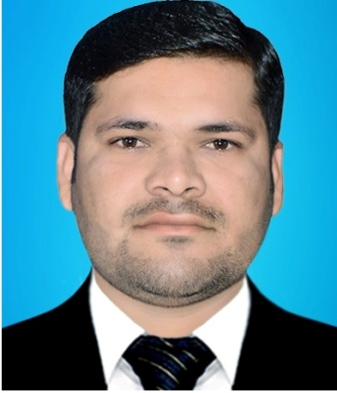
Objectives Obtain a IT specialist positions where I can maximize my skills and development.

Asif.375628@2freemail.com
Date of Birth
21/02/1994

English
Urdu
Sindhi

Microsoft Word
Microsoft Excel
Power Point

- Optimistic
- Patient
- Communicative
- Creative
- Exactitude
Education 2012 -2016 Sindh University Jamshoro Bachelor of Computer Science 2010 - 2011 B.I.S.E Larkana 0 Pre Engineering 2008 - 2009 B.I.S.E Larkana Science AA Experience
Asif

six months as an assistantant accountant experience and continue at Khaleej Traveel and tours Khaleej Traveel and tours Six month Teaching Experience
Four months work with EFU Insurance HOBBIES Work on New Technologies Watching News Talk Shows Playing Cricket Running Early in the Morning
Languages

PERSONALITY

Software Skills

