Tahira 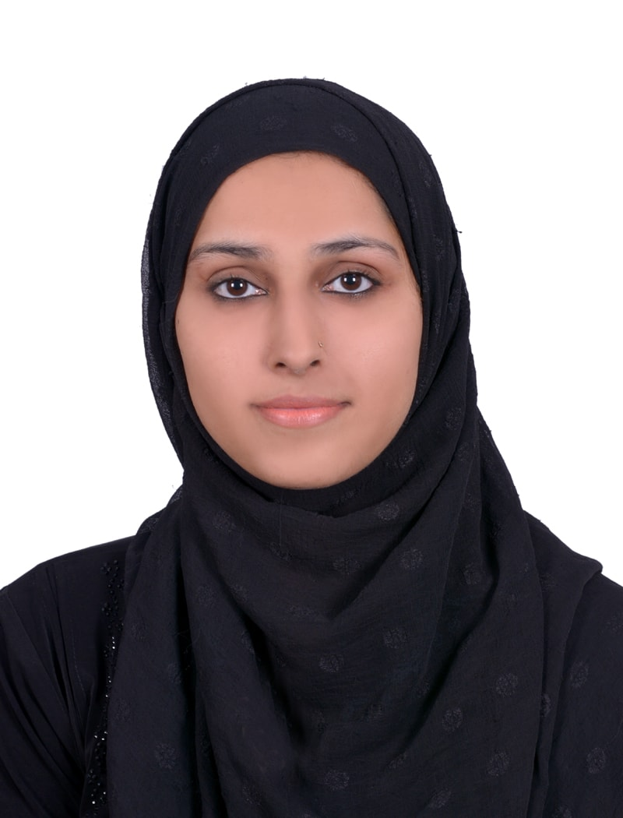

Montessori Teacher, English Teacher, Coordinator

Sharjah

Tahira.375640@2freemail.com
This is experienced qualified teacher having experience of more than 8 years in Teaching with my qualification MA (English), BA (General) and B.Ed.

My Objective is to obtain a position as an Elementary School Teacher that will utilize my strong dedication to children's development and to their educational needs and obtain a position at a institute where I can maximize my teaching experience, children's program development skills and my training abilities.

WORK EXPERIENCE

Montessori Teacher & Coordinator

Twinkle Stars School - Sialkot - July 2013 to July 2017

- Giving work programme to junior teachers and assessing their work
- Teaching English and Math’s to primary classes
- Making syllabus and class wise course curriculum
- Rhyme and Handwriting session to nursery and KG students
- Interaction with students and monitor their development
- Special care and attention to underperforming students through proper teaching and guidance
- First point of contact with parents for any issues related to student
- Administer the day to day functioning of school

Primary Teacher

Brook field School - Sialkot - May 2011 to April 2013

- Develop disciplinary instructional units in order to meet the individual needs of students
- Maintain ongoing dialogue with other teachers and coordinators to handle curriculum integration and implementation
- Maintain classroom environment by ensuring that appropriate behavior rules are followed and lesson plan is followed
- Ensure availability of materials and resources needed to further educational plans
- Demonstrate rapport with students by ensurings kinness and respect for each student
- Report discipline concerns that may be beyond classroom tactics to the school head
- Timely create progress reports of each student
- Train teacher assistants in order to make sure that they are ready to perform in their roles
- Maintain classroom supplies inventory and stock
- Complete and maintain student records in school’s database
- Participate in interview processes for hiring new teacher
- Develop teaching outlines and lesson plans
- Give lectures, facilitate discussions and activities
- Keep class attendance records, assign homework
- Taking English Class, Math’s Class & other subjects

Montessori Teacher

Brook field School - Sialkot - March 2009 to April 2011

- Promote the Montessori’s vision and objectives by creating appropriate curriculum
- Maintain ongoing dialogue with other teachers and coordinators to handle curriculum integration and implementation
- Work with individual students to gauge abilities and work towards catering to these abilities
- Use various assessment tools to evaluate each student’s capabilities within the classroom
- Prepare an environment conducive to learning and social and academic development
- Demonstrate rapport with students by ensuring kindness and respect for each individual student
- Report discipline concerns that may be beyond classroom tactics to the school head
- Ensure safety and emotional security of students and ensure that the physical environment of the classroom is in accordance to health and security directives of the school
- Establish a positive relationship with parents by ensuring regular and positive communication
- Timely create progress reports of each student
- Develop and participate in school functions such as orientations, projects and carnivals
- Complete and maintain student records in school’s database

EDUCATION

MA (English) in Linguistic English, Drama, Classical Poetry, Novel, American Literature

University of Punjab - Sialkot
June 2014 to February 2016

B.ED in School Organization, Perspective of Education, Psychology, English Teaching

Allama Iqbal Open University – Sialkot
September 2013 to June 2014

BA in Education, Child Development, English, Math’s, Economics
Allama Iqbal Open University Sialkot
March 2011 to August 2013

SKILLS

Microsoft Office, Tailoring & Handicraft, Arts & Drawing, Patience, Creativity

CERTIFICATIONS/LICENSES

Domestic Tailoring
Stitching, Designing
Spoken Language

PERSONAL DETAILS

Date of Birth: 22 September 1987
Marital Status: Single
Languages Known: English, Urdu, Arabic (Read only)
Nationality: Pakistan
Visa Status: 90 days Visit (Expiring on 10 January 2018)

