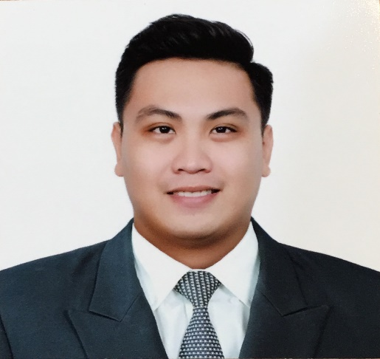
Francis
Francis.375649@2freemail.com

OBJECTIVE:
Seeking a challenging career with a progressive organization that provides an opportunity to capitalize my technical and subject specific knowledge and understanding in Civil Engineering.

SUMMARY OF QUALIFICATIONS/ SKILLS:
- Intermediate Knowledge in Autodesk, AutoCAD and the basics in STAAD v8i (Structure modeling and analysis), GIS (Geographic Information System), Adobe Photoshop and Proficient in Microsoft Office (Word, Excel, and PowerPoint)
- Well-versed in IBM Maximo EAM (Enterprise Asset Management). The world’s leading enterprise asset management solution that keeps the most critical assets and resources operating at maximum efficiency.
- Prepared project estimates, schedules and cost control of a Cable trench, Retaining Wall, Reinforced Concrete Box Culvert, and a 3 floor dormitory.
- Completed design calculations and drawing for a Storage Warehouse in CAD and STAAD.
- Created a Topographic map showing the different elevations of the coastal community that was affected by coastal erosion for mitigation purposes.
- Licensed Civil Engineer in the Philippines, PRC License No
- International Drivers’ License (Visit Visa)

ACADEMIC QUALIFICATIONS:
- Bachelor of Science In Civil Engineering
University of San Carlos – Cebu, Philippines

Core Courses: Construction Planning and Management, Cost Estimating and Surveying, Reinforced Concrete and Steel Design, Foundation Design, Water Resources Engineering, Geotechnical Engineering.

EXPERIENCE:
CIVIL SUPERVISOR
Khansaheb Facilities Management – Abu Dhabi, UAE
Project: Beach Palace, Sheikh Mansour Bin Zayed Al Nahyan Properties
Sept 2017 – Present
- Supervised the team to make sure the work is done properly and on time.
- Prepare Technical Reports and Material Request needed for the work.
- Ensures the workers are safe on site because safety is paramount.
- Prioritize the Reactive Maintenance work order that are reported on site.
- Conduct Monthly Fabric Inspection on all civil works.
- Prepare layouts of the work to be accomplished on CAD.
- Manage the monthly PPM (Planned Preventive Maintenance) on site.
- Well-versed in IBM Maximo EAM (Enterprise Asset Management).

CIVIL ENGINEER
Marguad Trading and Services – Cebu, Philippines
March 2015- April 2017

- Supervised the masonry works of projects according to plan and specification.
- Inspected and conducted quality work on site and checked punch list of errors to be rectified
- Interpret drawing/plans.
- Read and understand specifications.
- Review the AFC drawings for error purposes
- Responsible in fabrication process, lay-out and cutting activites.
- Examined daily fit-ups orientation of drawing and materials to be used.
- Received and conduct inspection of materials used on projects.

CIVIL ENGINEER INTERN
DDT Konstract Incorporated – Cebu, Philippines
January - March 2015
Project: Horizons 101 Tower

Rebar Engineering
- Prepared Bar Cutting list and Bar bending schedule for the beams, columns, and slabs.

Concrete Engineering
- Estimated the Volume of the foundation for Concreting
- Prepared Concrete Pouring and Inspection work request.

Quantity Survey
- Estimated the actual tiles used and compared it with the tiles per plan.
- Prepared the Bill of Quantities of the items of work identified by the drawings and specifications.
- Check on the accomplishment on each floor, inspect whether the windows, doors, water proofing, ceiling, are installed and whether the CHB are installed and plastered.

Quality Control
- Inspects quality work control on site and reviewed bar cutting list.
- Checked daily Operation Field Report.
- Checked punch list of errors to be rectified before concrete pouring proceeds.

PERSONAL QUALITIES:
- Positive attitude towards work and great ability towards result oriented output.
- Excellent Communication/ interpersonal skills to interact individuals at all levels.
- Flexible and Open to learn new things
- Can work independently or in a team.
- Proven ability to manage multiple tasks while meeting challenging deadlines.

SEMINARS ATTENDED:
- First Balfour Project Management Symposium
Febuary 5, 2013 – Participant
PROFILE:
Date of Birth: September 8, 1991
Age: 26
Gender: Male
Nationality: Filipino
Marital Status: Single
CHARACTER REFERENCE:
Available Upon Request

