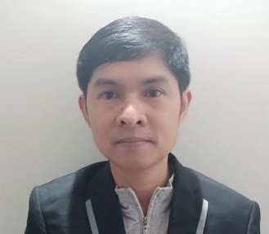
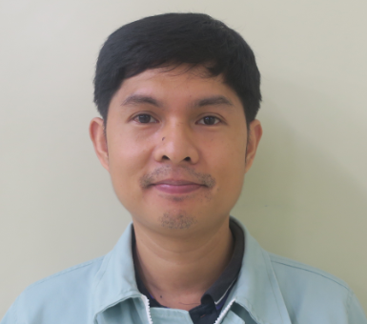
Dario
Dario.375664@2freemail.com

Objective:
To be able to work and be part of a good company where I am able to apply and contribute my skills and previous experiences to the organization.

Highlights of Qualifications:

- With Experience in Manufacturing and Sales.
- With experience in Production, QA, Manpower assignment Decision making, forecasting, and Planning.
- Possess interest in Skills development and a team player who thrives under pressure.
- With background in Microsoft office, software installation, GR&R Study, SPC Monitoring and Minitab.

Work History:

Toshiba Information Equipment Philippines, Inc.
HDD Design Support Centre, HDC3 Section
July 2015 – December 22, 2017
Planner/Evaluator

- Production Planner for new Model and Parts inventory in charge
- Discuss evaluation process requirement to Concerned Departments
- First Level FA Investigation of new model

Toshiba Information Equipment Philippines, Inc.
Enterprise Quality Assurance, EQA1 Section
January 2014 – June 2015
Process Engineer

- Key personnel in Cleanroom QA Production qualification
- Immediate superior of four shifting line leaders
- Production Auditor
- Conduct SPC Monitoring, GR&R study and Quality related analysis

Fujitsu Computer Products of the Philippines
General Quality Control, QAD Section
December 2012 – December 2013
Calibration Technician

- Perform calibration of Measuring tools and equipment
- Responsible in monitoring and controlling calibrated equipment
- Provide Technical support to other department for handling and maintenance of measuring tools equipment.

Fujitsu Computer Products of the Philippines
Manufacturing Department
October 2009 – November 2012
Line Leader

- In charge in daily, weekly and monthly production status
- Maintain and assigned workloads for 4 Sub leaders and 54 Operators.
- Assigned personnel for work procedure and workflow revision
- Safety officer

Lianas
October 2007 – September 2009
Department Store Supervisor

- Immediate superior of department store personnel’s
- In charge for inventory, sales report and costumer complaints

AFP Enlisted Personnel Clubhouse
September 2007 – October 2008
Solcom Canteen Assistant Supervisor

- In charge for remittance and daily canteen budget.
- Treasurer, Cashier and receiver of advance order menu

Educational Attainment:
Bachelor of Science in Industrial Engineering Manuel S. Enverga University Laguna College Laguna College (secondary) San Gabriel Elementary School San Gabriel San Pablo city (primary)

Personal Background:

Date of Birth : April 8, 1976
Place of Birth : Tanay Rizal, Philippines
Citizenship : Filipino

