CURRICULAM VITAE

KETA
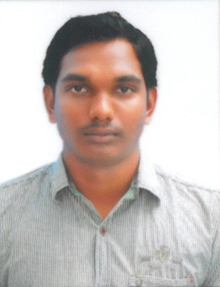
Email: keta.375674@2freemail.com

- OBJECTIVE

Aim to be placed in a challenging organization that gives me scope to update my knowledge & skills in accordance with the latest trends and be a part of team that dynamically works towards growth of organization thereof.

SUMMARY:

- B.Tech(EIE) from “CEC COLLEGE” in 2013
- Having 3+ years of industrial experience
- Consistently good academic record
- Good analytical& communication skills

- EDUCATIONAL QUALIFICATIONS

NAME OF EXAMINATION | INSTITUTION&YEAR | MARKS
Bachelor of Technology  (Electronics& Instrumentation) | Chirala Engineering college, JNTUK University, A.P  (2010-2013) | 65.79%
DIPLOMA (Electronics& Instrumentation) | SMVM ,( S.B.T.E.T (A.P)2007-2010) | 70.1%
Board of Secondary  Education(10th) | SNPZP HIGH SCHOOL, A.P  (2006-2007) | 67.8%

- EXPERIENCE

I have 3 years 1month experience in Calibration Field, Since Jul 2014 to Aug 2017.

Works at VIGNAN INSTRUMENTS as a Instrumentation Engineer in pharma industries.

- Technical skills

- Experience on hot point checking and cold point checking from maintained room temperature.
- Planning, scheduling of Service for Testing & commissioning.
- Calibration for field instruments (pressure, temperature).
- Receiving day-to-day progress of the job with the consultant as per planning schedule and reporting the progress of the job with the clients.

- In this field I know the calibration of RTD Sensors, Thermocouples, Pressure guage, Magnehelic guage, Compound & Vacuum guage, Pressure Transmitter, Temperature Transmitter, Differential Pressure Transmitter, PH Sensor, Conductivity Sensor.

- STRENTHS

- Good communication skills ,interpersonal skills and leadership qualities.
- Ability to work pressure and task oriented environment.

- SOFT SKILLS

  - MS-OFFICE & MS-EXCEL .
- Operating Systems :Windows XP,Vista & Windows 7,8.
- System operating & Photo shop.

- LANGUAGES
- SPEAK - Telugu ,English,
- READ - Telugu ,English, Hindi
- WRITE - Telugu ,English, Hindi

- PERSONAL DETAILS

Name : Keta
Gender : Male
Marriage : unmarried
Date of Birth : 19 Aug 1992
Nationality : Indian
VISA STATUS : VISIT VISA

- DECLARATION

I hear by solemnly declare that the above furnished details are true to the best of my knowledge.

PLACE: Dubai
DATE : (KETA )

