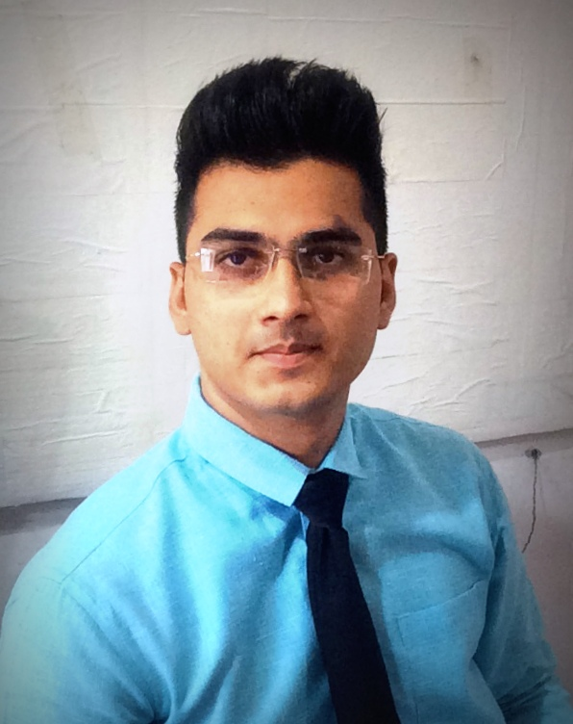

Thoroughly dedicated, sincere, tactical and rational Civil Engineer with good record of construction projects. Credible and loyal character who believes in work and to contribute something effective to the industry on a possible way. Conscience about work and ability to deal scrupulously in various circumstances. Adept at coordinating with building and engineering professionals for every project stage. Always thirsty for knowledge and believing eternal reading and learning.

**PROFILE**

**KEY ACHIEVEMENTS**

* Effectively handle the whole building site up to 18M as a solo project foreperson, engineer, supervisor and manager where during whole tenure I used to handle purchase, store, quality, quantity survey and other miscellaneous works. *(Vadodara 2014-15)*
* Successively finished complicated exterior work of Aluminum Composite Panel according to design which is visible at my blog. The work was quiet challenging and interesting. *(Vadodara 2014-15)*
* Due to working as Site Incharge it pour confidence to handle the whole job which improved my work efficiency, productivity, capacity & maturity. *(Vadodara 2014-15)*
* Successively worked up to 2M without any senior engineer at site and achieve maximum productivity during my charge as trainee engineer. *(Lunawada 2013-14)*
* During collage time involved various billing work of private firms to gain some income to support family financially. *(Gujarat 2015-17)*

HiREN

Construction Planner & Engineer

**CONTACT**

[Hiren.375677@2freemail.com](mailto:Hiren.375677@2freemail.com)



30/06/1995



**CAREER**

**August 2015-Now**

**Quantity Surveyor**

**& Billing Engineer**

**PRIVATE FIRM │** *Surat , Vadodara & Ahemdabad*

Consulted contractors for computation of finished work and bill clearance from their respected clients. This work has improved my quantitative skill at a professional level**.**

**NATHDWARA DEVELOPERS │** *Vadodara*

Consulted various contractors and labors for execution of work and played role of site engineer, supervisor, quality and billing engineer as well as purchase engineer under various critical circumstances which enhanced my various skills such as scheduling, monitoring, executing and dealing with various stakeholders in any situations.

ENGLISH

**LANGUAGES**

**March 2014-August 2015**

**Site Incharge**

HINDI

GUJARATI

MARATHI

**SKILLS**

**July 2014-October2014**

**Contractor**

**PRIVATE CLIENT │** *Vadodara*

Construction of a house and types of works are such as excavation, shuttering and RCC work which pour the confidence to take the work on individual level.

ANALYTICAL

LEADERSHIP

**SPECTRUM ENGINEERS │** *Lunawada/ Panchmahal.*

Interacted with client (government authorities) for construction work and convince up to their standards. Successfully handled labors and supervisors for execution of the work within minimum expenditure. Introduced by various activities such as leveling of canal using dumpy level, excavation, formwork and concrete work.

CREATIVITE AND ARTISTIC

**November 2014-March 2015**

**Trainee**

**Engineer**

TEAMWORK & MANAGMENT

COMMUNICATION

ORGANISATION

MARKETING

**KEMA ENGINEERS │** *Vadodara*

Introduced by various fabrication job which address at Vadodara Railway Station, work is subjected is to make staging for escalator.

**Oct2013-Nov2013**

**Intern**

**REFERECNCES**

Available on Request

**EDUCATION**

**August 2015-May 2018**

**Bachelors of Civil Engineering**

**NEOTECH INSTITUTE OF TECHNOLOGY │** *Vadodara*

After 22M of site experience, it was great to learn again in collage. I got such opportunities to participate in various cultural and technical events and industrial visits. The score is 8.10 CGPA till Aug.2017 and expecting to complete my graduation till May2018.

**SHRI K.J. POLYTECHNIC │** *Bharuch*

Definition of Civil engineering and concept of engineering and the connection between concept and execution was cleared. The score was 6.0 CGPA from Gujarat Technological University.

**August 2010-June 2013**

**Diploma in Civil Engineering**

**PRINCIPLES OF CONSTRUCTION MANAGEMENT**

Successfully completed particular program and score was **56%**

**Aug2017-Oct2017**

**NPTEL Online Certification**

Indian Institute of Technology, Kanpur

**Jul2016-Sept2016**

**NPTEL Online Certification**

Indian Institute of Technology, Madras

**SARDAR VALLABHBHAI VIDHYALAYA │** *Vadodara*

Successfully completed Secondary School from Sardar Vallabhbhai Vidhyalaya. The score was 72% from Gujarat Secondary & Higher Secondary Education Board, Gandhinagar.

**March 2010**

**Secondary School Certificate**

**COURSES**

**PROJECT PLANNING AND CONTROL**

**Elite** in particular program and score was **83%**.

**SOFTWARES**

**PrimaVera**

**P6**

**REVIT**

**Staad-Pro**

**AutoCAD**

**MsProject**

     

**WORKSHOPS & SEMINARS**

* 3 Dimensional Success **│** *Vadodara 2017*
* How to add 50000 productive hours to your life **│** *Vadodara 2017*
* Innovation Conference on Disruptive Innovation **│** *Ahemdabad 2017*
* International Conference on Energy & Infrastructure Management **│** *Gandhinagar 2015*
* Workshop on Zero Energy Building at Indian Institute of Technology **│** *Mumbai 2015*

**ACHIEVEMENTS & AWARDS**

* 3 times all India Judo Championship Participant  **│** *2007-2010*
* 5 times district and 4 times state Judo champion. **│** *2007-2012*
* 3 times district and 1 time state champion and bronze medalist in wrestling. **│** *2008-2012*
* Runners up in Fort building competition held at Shri Fatehsingh Museum, Vadodara. **│** *2012*
* Participated in “ON THE SPOT COMPITION OF PAINTING” on Swami Vivekanand- Life & Message. **│** *2013*

**+**

**HOBBIES AND INTERESTS**

     

**HOBBIES & INTERESTS**