AJIT
IT Hardware and Networking

Gurgaon, HR, India | ajit.375685@2freemai.com
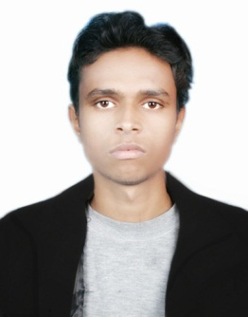

- Quickly catching the computers problems and Troubleshoot it
- Quick learn any new things in computer
- I'm punctual and hard worker

Work experience
2017/01 – 2017/09 |  | Computer Operator
 |  | Orient Craft Limited
- Gate Inward entry on ERP software
- Troubleshooting Computer Hardware and Networking Problems
2015/05 – 2016/02 |  | AUTOCAD Draftsman
 |  | Dedhua Engg Pvt Ltd
- Create 2D Drawing for Indian Railway Track on AUTOCAD 2014
- Preparation of all survey data in Excel Sheet

Qualification
2009 – 2013 |  | Bachelor of Commerce (B.Com Honors)
 |  | Veer Kuwar Singh University
 |  | Accounts Honors
2006 – 2008 |  | 10+2(Intermediate)
 |  | Maharshi Vishvamitr College
 |  | Intermediate Science
2005 – 2006 |  | 10th (Matriculation)
 |  | Multi-Purpose High School

Education
2013 – 2015 |  | IT Hardware and Networking Diploma
 |  | JETKING Hardware and Networking Institute
 |  | - Computer Hardware and OS
 |  | - Computer Networking
 |  | - CCNA- RIPv1v2, OSPF, EIGRP
 |  | - Windows server 2008
 |  | - Ethical Hacking Basic
2008 – 2009 |  | Accounting
 |  | Aptech Institute
 |  | - Accounting- tally 7.2, tally 9.0 ERP
 |  | - MS Office

Skills
IT Skills
- Configuration CCNA RIPv1v2, OSPF, EIGRP
- LAN configuration both wired and wireless
- Configuration Windows server Roles and Features
- Create Domain or Domain Client
- Installation Windows xp, vista, 7, 8, 10, 98, server 2008
- Troubleshooting Computer Hardware and software Problems
- Installation and Troubleshooting Printing problems
Technical Skills
- Extremely Knowledge of MS Office focus on Excel
- Configuration and Troubleshooting MS Outlook
- Data Entry- typing speed 45wpm
AUTOCAD 2014
- Creating 2D and 3D drawing

Personal Information
Marital Status- Married
Sex- Male
Nationality- Indian

Declaration
I hereby declare that all the information given above is true to the best of my knowledge and belief.

