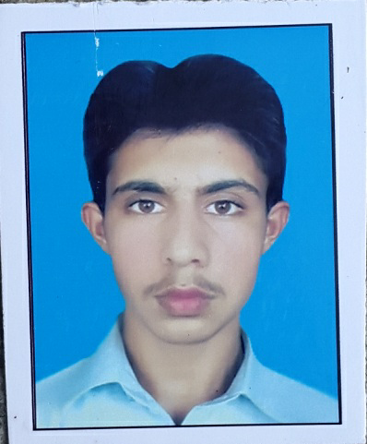

SHAHAB

Email : SHAHAB.375700@2freemail.com
Mobile: Whatsapp +971504753686 / +919979971283

CAREER OBJECTIVE

To apply my knowledge and skills for the mutual benefit of myself and the organization for which I work. To prove myself as an innovative and contributory team member towards the growth and development of the organization.

PERSONAL INFORMATION

Religion Islam
Nationality Pakistani
Domicile Mardan (KPK)
Visa status Tourist Visa
DOB 23 March 1996
Marital Status Single

ACADEMIC QUALIFICATION

- Matric 2012 Tameer-e-seerat public school & college Swabi
- DAE(Civil) 2015 Gov. college of technology swabi (kpk)
- AutoCAD 2015 Sublime institute swabi
- Lab tech course 2016 CTTI Islamabad
- Total station(special course) 2016 Swabi polytechnic institute
EXPERIENCE & SKILL

- 1 year experience in C&W Swabi as a site trainee
- Work on Road construction, building construction, Making Maps
- Quantity survey: Identify Steel quantity, concrete quantity, Aggregate quantity, Bricks quantity of any sort ,with full command over it.
- Lab technician: Expert in soil test ,aggregate test, asphalt test, bitumen test,cement & concrete test
- MS office
LANGUAGES

- English
- Urdu
- Pashto

