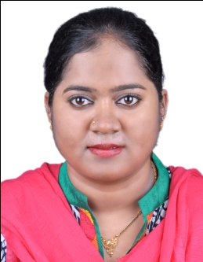
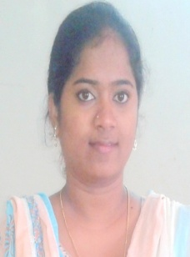
ASMA Email – asma.375701@2freemail.com
Address: Al Karama, Dubai

Entry Level Professional

Profile Summary

- An innovative thinker with over 4 years of experience in Customer Support and certified trainer from Cognizant.
- Proficient in reviewing and executing Test Cases.
- Skilled in maintaining Test reports which support production team to ensure consistency and stability.
- Knowledge on Functional, Integration, and System Testing. Strong in SDLC, STLC and Defect Life Cycle.
- High level of computer literacy (MS Word, Excel, MS PowerPoint).
- Highly capable of multi-tasking on a limited time scale.
- Ability to work under pressure and meet deadlines.
- Flexible to work independently or with a team.
- A team player with strong communication, analytical, logical and problem-solving skills; capable to work under pressure situations and meet deadlines.
- Fluent in English (US, British), Hindi, Kannada.

Skill Set

Functional Testing, System Testing etc
US healthcare customer service and claim processing.
Worked as a Trainer in Cognizant.

- Networking
- MS Office
- SQL
- Software Testing

Basic Knowledge

Work Experience

- Oct’14 to Aug’17 with Cognizant Technology Solutions
Growth Path:
Oct’14 to Aug’17 worked as Senior Process Executive (Voice) in US healthcare.
Jul’16 to Aug’17 worked as trainer and subject matter expert in US healthcare.

Job Description:
- Third party between US providers and insurance companies, working on the provider’s end, provides support to US providers to get the medical claims status from insurance companies, resolving the claims completely and updating the same in the client’s system.
- Third party between US insurance companies and providers, working on the insurance company’s end, provides support to US insurance companies by assisting the providers on the claims.

Highlights:
- Rewarded with the Spot Award for Excellence in Quarter Q1 16-17, Q3 15-16.
- Certified trainer from Cognizant in US healthcare.
- Took up additional responsibility as on job trainer and involved in software testing.
- Attended client calls related to project development.

- Sep’13 to Oct’14 with Omega Healthcare
Worked as Executive AR
- Worked as free lancer software tester for Saucony project.

Education

- B.E. (Electronics & Communication) from B.I.E.T Davangere affiliated to VTU Board Karnataka, India.
- Diploma (Electronics & Communication) from A.E.I.P Gadag affiliated to Department of Technical Education Board Karnataka, India.
- Testing course from STL Bangalore, India.

Personal Details

Date of Birth | 13-Apr-1987.
Marital status | Married.
Nationality | Indian.
Visa status | From 22/12/2017 to 20/03/2018
Languages Known | English, Urdu, Hindi, Kannada.

My Husband (Mohammad) is working in Gloria Hotel as Supervisor, Dubai. So I am relocating to Dubai. My Brother (Azharuddin) is working in TGT Oil & Gas Company as Desktop Engineer in Dubai.

Declaration

I hereby declare that the information furnished above is true to the best of my knowledge and I would like to assert to the full of my satisfaction that, I would put in my best efforts in the organization and work for the best possible results.

Date: Signature
Asma

