CURRICULUM VITAE. 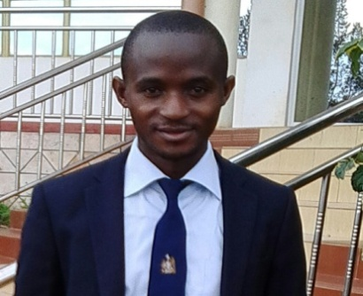

NAME: WASWA
Email: WASWA.375709@2freemail.com
Mobile: Whatsapp +971504753686 / +919979971283
Address: Dubai, UAE
Visa status: Visit visa
Nationality: Ugandan
Marital status: Married
Languages: English
QUALIFIED AND REGESTERD TEACHER
PROFILE
Highly experienced, detailed oriented, disciplined resourceful professional candidate with exceptional skills, flexible personality and adaptability to new working environments.
EMPLOYMENT HISTORY
LONDON COLLEGE OF ST LAWRENCE (2014 -2017) KAMPALA/ UGANDA
TEACHER
Responsibilities.
- Teaching biology and chemistry to learners in their specified periods as assigned.
- Carrying out practical so as to enhance learners
- Taking learners to field work tours outside schools s
- Guiding and counselling learners
- Maintenance of general cleanliness of learners through giving advice the place.
- Ensure that students have got satisfaction of the services we render.
- Ensure quality and quantity of services rendered to our customers

ST JOSEPH OF NAZARETH HIGH SCHOOL KAMPALA (JAN 2012-2014)
TEACHER
Responsibilities
- Teaching biology and chemistry to learners in their specified periods as assigned.
- Carrying out practical so as to enhance learners
- Taking learners to field work tours outside schools
- Guiding and counselling learners
- Maintenance of general cleanliness of learners through giving advice the place.
- Ensure that students have got satisfaction of the services we render.
- Ensure quality and quantity of services rendered to our customers
SKILLS AND COMPETENCIES.
- Very good in practical skills
- Hard working, determined and dedicated.
- Believe in team work and ability to handle pressure.
- Positive attitude and punctuality.
- Good communication skills.
HOBBIES
- Carrying out various practical to explore new things
- Making research
- Meeting and making new friends.
EDUCATION BACK GROUND
- Bachelors degree in science with education from Makerere University
- Certificate of in service training
- Uganda Advanced Certificate Of Education
- Uganda Certificate Of Education
Attached are my academic transcripts

