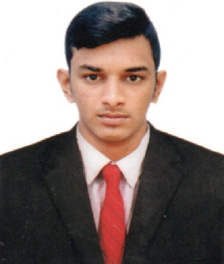
AL
MECHANICAL ENGINEER
Full Name : Al
Email : al.375758@2freemail.com

OBJECTIVE

To pursue a highly rewarding career seeking for a job in challenging and healthy work environment where I can utilize my skills and knowledge efficiently for organizational growth as well as personal career growth.

EXPERIENCE Duration: AUG 2016-AUG 2017

Have one year experience in Automobile Company at PHA India private limited in Chennai.

PERSONAL SKILLS

- Ability to work as a team
- Flexible at working
- Adapting and improvising to various situations.
- Effective Communication Skills & Quick Learner

TECHNICAL SKILLS

Computer Skills:

- MS Office: Well-versed in MS Office application
- Browsing: Accustomed to the use of the internet for data searching and mining
EDUCATIONAL QUALIFICATIONS
ANNA UNIVERSITY, CHENNAI, INDIA  VINSChristian College of Engineering | 2016
BACHELOR OF ENGINEERING (MECHANICAL)
CGPA FIRST CLASS 69.1%
TAMILNADU STATE BOARD, INDIA  Govt Higher Secondary School,Thengapattanam | 2012
HIGHER SECONDARY EDUCATION
PASS PERCENTAGE: 71.75%
TAMILNADU STATE BOARD, INDIA  Govt Higher Secondary School,Thengapattanam | 2010
SECONDARY SCHOOL LEAVING CERTIFICATE (SSLC)
PASS PERCENTAGE: 73.2%

AL PAGE 2

PROJECTS UNDERTAKEN
- EXPERIMENTAL INVESTIGATION OF NATURAL FIBER REINFORCED EPOXY COMPOSITE (Academic)
Description: An Experimental investigation to explore the potential of using PALF as reinforcement and
investigate the mechanical effect of PALF forced epoxy composite and analyze the materials application as a leaf spring etc..

ACHIEVEMENTS
- ACADEMIC:
Participated of one day workshop in CREO PARAMETRIC at EduCADD at Nagercoil

EXTRA CURRICULAR ACTIVITIES:
  - Actively participated in the seven day National Service Scheme(NSS) camp in Mulloor- thurai

PERSONAL INFORMATION
    - Name : Al
    - Date of Birth : 29 Dec 1994
    - Nationality : Indian
    - Languages : English, Malayalam, Tamil
    - Marital Status : Single
    - Religion : Islam
    - Visa Status : Visit Visa (Valid Till 22 Jan2018)

OFFICIAL DECLARATION
I hereby declare that the above information is true to the best of my knowledge.

PLACE : DUBAI
AL

