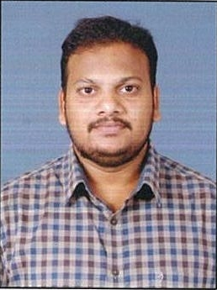
RESUME
ASHOK
(ON VISIT VISA DUBAI)

Email : ashok.375779@2freemail.com

SUMMARY

SUMMARY:
Having 4+ years of hands own experience in HVAC projects execution, engineering & management in warehouses, High rise, commercial and residential building construction projects. Preparation, execution & monitoring, testing and commissioning of services like HVAC, PLUMBING (drainage ,water supply, chiller piping, pumps) FIRE FIGHTING as per compliance with plan, shop drawing ,specification, standards and schedule .Having good experience in the field of Quality Control Engineering, Site Engineering ,preventive maintenance engineering .
QUALIFICATION AND SKILLS

2009-2013 | Bachelor of Engineering (B.E) degree mechanical. | Avanthi’s College Of Engineering visakhapatnam (Affiliated to JNTUK, Kakinada)
JUNE2013-OCT2013 | Professional HVAC training & REVIT MEP . | SVS MEP consultants and HVAC training institute  Visakhapatnam ,ANDHRA,PRADESH
2013-2017 | HVAC ENGINEER | MICRON ELECTRICALS  HYDRABAD,INDIA.
PROFESSIONALISM
- I have joined HVAC-R carrier in NOVEMBER -2013.
- Sound exposure in HVAC like ASHRAE,ISHRAE, plumbing codes like NFPA,IPC.
- Adept in DX & Chilled water systems, FCU’s, AHU’s, Chillers, cooling towers, package roof top units, Exhaust fans ,VRF air conditioning systems, Multi split air conditioners systems and requirement.
- Sound exposure in HVAC equipment selection, Duct materials selection and Duct sizing & equipment selection like pumps and valves.
- Sound exposure in Dry and wet Fire fighting sprinkler system.(deluge and pre action systems).
- Accountable for timely execution of site activities as per approved drawings, client specification & local authorities.
- Coordinate & review the builders work drawing with the MEP contractors.
- Track record of targeting zero safety violation of team members, in terms of PPE and other works carried out at site.
- Deft in preparing daily work plans and ensuring that PTW and safety measures for better HSE are completed before the start.
- Preparation of Daily, Weekly, and one month progress report.
- Mobilization of manpower for execution of the project.
- Perform the required assessment needed, check and evaluate of the equipment condition.

PERSONAL INFORMATION

DATE OF BIRTH | 21st JAN 1992.
LANGUAGE KNOWN | ENGLISH/ HINDI/ TELUGU
MARITAL STATUS | UN-MARRIED

