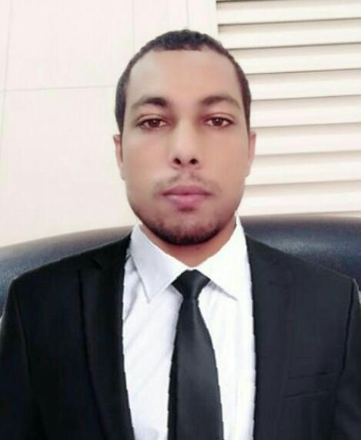
2015- june 2016

Agst 2016 present
Mohammad

Mohammad.375787@2freemail.com

OBJECTIVE

• Sales position where I can utilize my retail sales, cash management, and supervisory skills.

KEY QUALIFICATIONS

- Greeting customers who inter the shop.

- Be involved in stock control and management.

- Assisting shoppers to find goods and product they are looking for.

- Stocking shelves with merchandise.

- Answering the queries from customers.

- Reporting discrepancies and problems to the supervisor.

- Giving advice and guidance on product selections customers.

- Responsible dealing with customers complaints.

- Working with established guidelines particularly with brands.

- Receiving and storing the delivery of large amounts of stocks.

- Keeping up to date with special promotions and putting up displays.

WORK EXPERIENCE

Dizizone computer pvt. Ltd. Lucknow india
Sales man | 2014-2015

• Recommend, select, and help locate or obtain merchandise based on customer needs and desires.

Noor Al Nahda Technical Services L.L.C. Salse man

Ganga Electronics pvt. ltd. New Delhi India Merchandiser

• Describe merchandise and explain use, operation, and care of merchandise to customers.

EDUCATION

Dr. R.M.L. University U.P. India
Bachelor of commerce graduted, 62 | May 2015
Gt infotech
Computer hardware networking Diploma , 75 | 2013
Adarsh inter college faizabad U.P. India
Intermediate , 61 | 2012
Adarsh inter college
Highschool , 65 | 2010

COMPUTER SOFT SKILLS

Computer hardware networking : Basic knowledge of computer hardware networking

PROFESSIONAL QUALIFICATION

- CCHN PRO.(Computer hardware networking engineer)

- Basic knowledge of computer

PERSONAL DETAILS

Name | : | Mohammad
Date Of Birth | : | 13/03/1995
Nationality | : | Indian
Gender | : | Male
Marital status | : | Single
Religion | : | Muslim
Language Know | : | English,Urdu,Hindi
Passport | : | exp 29/04/2025
VISA | : | Exp(18/10/2019)
Hobbies | : | Playing cricket,reading and swimming

DECLARATION

• I hereby confirm that information provided is correct and true to the best of my knowledge

15-Oct-2017 Dubai
Mohammad

