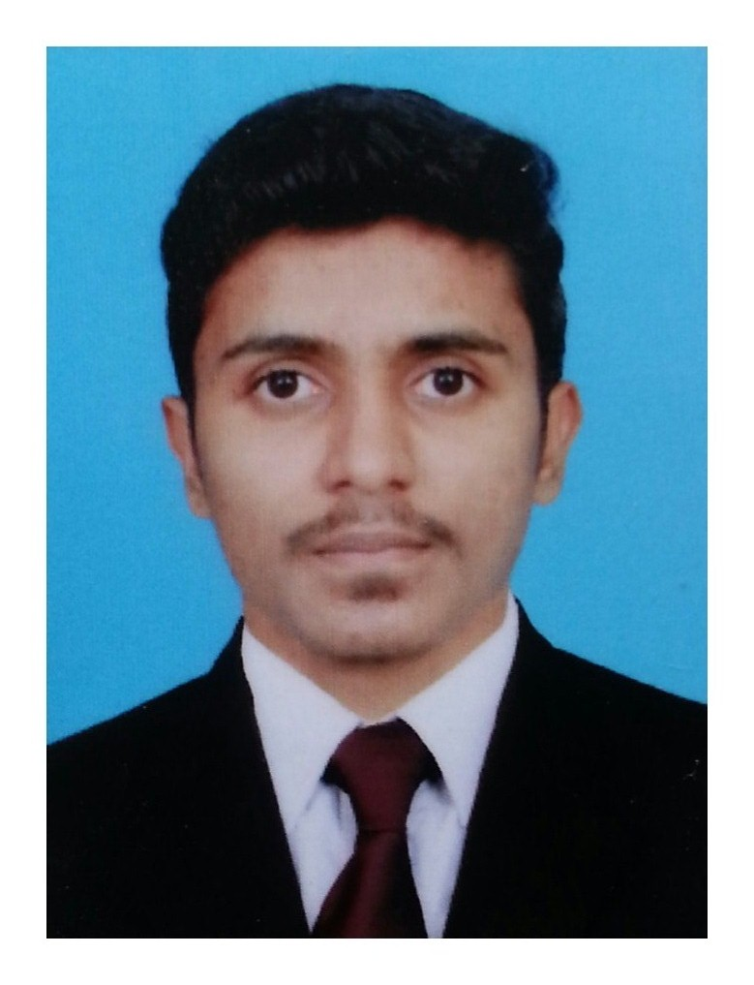
ansar
Email: ansar.375792@2freemail.com
Dubai, UAE

Career Objective

To be a Successful Professional In Store Keeper by Joining An Organization That Can Provide Me Opportunities To Widen My Skills To Grow & Expand With The Organization.

Profile Summary

- Have 19 Months of experience in Production Supervisor And Store Keeper.
- Have 18 Months of experience in Store Keeper And Accountant
- Well versed in computerized accounting Tally ERP 9, & MS Office Applications.
- Wide exposure to Production And Manufacturing procedures.
- Energetic and capable of working independently and a good deal of autonomy.
- Have excellent time management skills

Areas of Expertise
- Time Management  - Managing Staff | - Improving Processes  - Reducing Costs | - Dispatch Planning  - Improving Processes

Professional Experience

Production Supervisor And Store Keeper , M/s CUBIX FOOTWEAR CO, Calicut ,Kerala ,India
Job Profile:

- Ability To Organise Manage Motivate And Challenge A Production Team To Exceed Expectations.
- Visual Inspection ,Quantity And Quality Check With Department Personal
- Managing Staffs or Employees
- Make More Product In Short time
- Good Communication And Interpersonal Skills
- Able To Work Under Own Initiative
- Weekly Procurement Delivery Report And Store Material Status

Store Keeper And Accountant, M/s. P.P.M TRADERS Malappuram , Kerala, India
Job profile:

- Inventory Control Including Defining Slow And Non –Moving Items
- Handling or Maintaining Stores
- Arranging Materials As Requirement, Preservation ,Proper Tagging Of New Received Materials And Updating Location In System
- Enter all scanned documents, including receipts, checks, statements

Accountant & Tax Consultants M/s RAZACK & ASSOCIATES, Calicut ,Kerala ,India
Job Profile:

- Preparation And Filing VAT Returns Monthly
- Handling Advance Tax ,Sales Tax, Service Tax
- Reconcilation Of Banks .
- Provide Advice To Clients About Finance And Tax Options

Education

B.COM (CORPORATION) CALICUT UNIVERSITY
PLUS TWO –COMMERCE BOARD OF HSE ,KERALA
SSLC BOARD OF PUBLIC EXAMINATION, KERALA

Computer and IT skills

- MS OFFICE Applications (WORD,EXCELL,POWER POINT)
- Accounting Applications Like TALLY ERP 9 And, EASY BIZ ,TASK RITS OS ,TAX SOFT

Personal Profile

Date of Birth 26/05/1994
Nationality Indian
Marital Status Single
Age 23
Languages Known English, Hindi, Malayalam, and Arabic (read and write)
Driving Licence Indian Two & L M V Licence
Visa Status Visiting Visa
Visa Exp Date 20/02/2018
Passport Exp Date 10/08/2024

