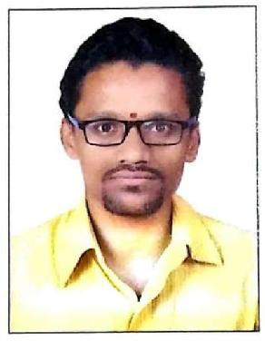MR. RUTURAJ
RUTURAJ.375795@2freemail.com
Mobile: Whatsapp +971504753686 / +919979971283

Site Engineer

Kruti Infracons Pvt.Ltd.,

Development of NIFT campus at plot no-20, Sector-4, Kharghar,410210, Maharashtra, India.

CAREAR OBJECTIVE

Results-driven, quality-focused Construction civil engineer with experienced in construction industry. Creative thinker and problem solver, able to make sound decisions and multitask to meet-competing deadlines. To secure the position in Construction Sector Which would help me to develop new skills in construction management and building new construction strategies thus exploring my full potential as well as contributing towards the development of the company.

PROFESSIONAL EXPERIENCE (2 YEAR)

- I worked at Kruti Infracons Pvt.Ltd, along with CIDCO (PMC department) , Consulting Engineering Service (Architect and Structural Designer) and Client NIFT Central Government (National Institute Of Fashion Technology)

From June 2016 to October 2017 (Duration 1 year 4 months)

Working as Site Engineer in Execution Department of Kruti Infracons Pvt Ltd, at Development of NIFT campus Plot No 20, Kharghar, Navi Mumbai, Maharashtra
JOB PROFILE-SITE MANAGEMENT

DUTIES & RESPONSIBILITIES
Delivered high standards in efficiency, quality and team management and Site Execution
Coordinating, scheduling, directing and motivating, personnel and subcontractors.

Site Execution and Reviewed and monitored building schedules and priorities to ensure projects progressed at expected pace.
Detail Quantity Estimation of all construction material require on site. Ensured all materials, installations and constructions met specifications by competently managing inspection of materials and quality of work, promptly identifying issues, and present reports and recommendations to senior project managers.
Work alongside Site Engineer, General Contractor and Architect on inspection of projects

and assist architect in preparing reports on areas requiring attention. Coordination with the client and PMC department.
Managed scheduling of labour, material and equipment deliveries to ensure optimal productivity and cost efficiency.
To prepare drawing in Auto Cad software for Quantity calculation and use Autodesk QTO software for taking out all quantities.
To prepare drawing on Auto cad software for construction methodology with alternative methods according to different site condition and construction sequences.
Client and Sub-contractor billing.
Recording Measurements for the executed works and get it approved by CIDCO (PMC dept.) and Client NIFT
Preparation of (B.B.S.) Bar Bending Schedules.
Timely Indenting of Construction Materials to Store Department. Ensuring Quality in Execution of civil structures.
Attending Site Review Meetings with the Client, PMC department and Management. Maintain the site best way possible to avoid internal quarrel if any with solving minor dispute
Send daily progress reports via mail to head office and establish effective communication with site staff PMC department and client.
- I worked at Unity Infraprojects Ltd, along with CIDCO (PMC department) , Consulting Engineering Service (Architect and Structural Designer) and Client NIFT Central Government (National Institute Of Fashion Technology)

From March 2013 to October 2013 (Duration 8 months)

Working as Trainee Engineer in Execution Department of Unity Infraprojects Ltd, at Development of NIFT campus Plot No 20 and 15, Kharghar.

DUTIES & RESPONSIBILITIES
8-month project training as a trainee engineer at 10 storeys N.I.F.T. hostel project and Academic building. Supervision of Formwork and reinforcement of columns, beams, slabs and casting of columns, beams, slabs.
Carried out different tests on construction material like concrete strength test, mortar test, steel test, timber test, sand test etc.
Supervision of finishing items like masonry work, plaster, flooring, plumbing, painting work.
Submit Daily work measurement of each work to Billing Engineer, Daily reporting to Sr. site engineer and General Manager.
Experienced in handling teams at site of construction.

EDUCATION

Bachelors of degree in civil engineering (Pune University) Sept 2013 - June 2016 Shree Ramchandra College of engineering.
Diploma in civil engineering (M.S.B.T.E.) August 2009 - June 2012
Government polytechnic pen.

COMPUTER PROFICIENCY

Operating System: WindowsXP,7&8,2000, OSX (apple)
MS Office, MS excel, Power point
AutoCAD.
Stad Pro.
AutoCAD structure Detailing.
QTO Software (Quantity Take Off)
AREA OF INTEREST

Project planning, scheduling and monitoring.
Execution of critical civil engineering structures.
Estimation and costing. Making of BOQ (Bill of Quantities)
All laboratory test as per specification like Cube, Soil, Sand, Cement and Aggregates test etc

CORE COMPETENCIES

 |  |  | -
 |  |  |  |  |  |  |  |  | with external and internal people.
 | PERSONAL PROFILE
Date of Birth |  |  |  |  |  | :24th July 1994
Nationality |  |  |  |  |  | : India
Religion |  |  |  |  |  | : Hindu
Marital Status |  |  |  |  |  | : Unmarried
Hobbies |  |  |  |  |  | :Music, Learning New Things, Internet Surfing
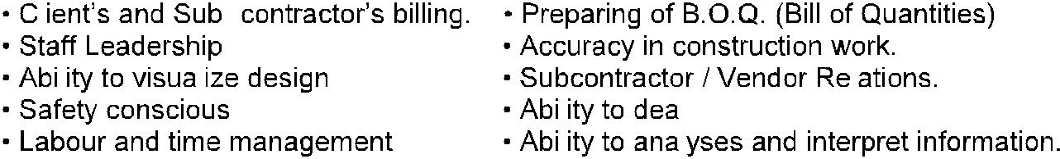
DECLARATION

I hereby declare that all the statements made above are correct to the best of my knowledge and belief.

Place: Sharjah, U.A.E. Yours Faithfully,

