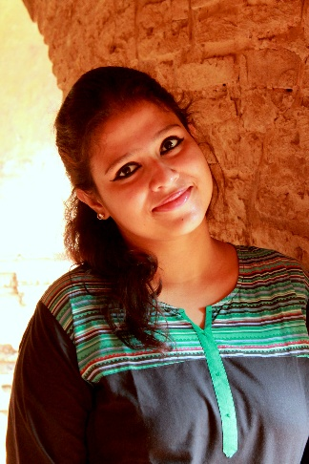

**Bachelor in Design (F.D)**

(Batch 2008-2012)

National Institute Of Fashion Technology

**CURRICULUM - VITAE**

**EDUCATIONS**

**MBA-Project Management**

PASSING YEAR 2015

SIKKIM MANIPAL UNIVERSITY

DISTANCE EDUCATION

To work in challenging and intellectually stimulating environment which offers avenue of growth ,based on capabilities and hard work . I want to utilize and enhance my knowledge to create value with my design skill and people management skill .

Debolina

**OBJECTIVE**

**EXPERIENCES**

**(2016,FEBRUARY TILL DATE ) FASHION DESIGNER CUM MERCHANDISER CUM BUYER**

**RETAIL : BABYSHOP (LANDMARK GROUP,DUBAI)**

**(2013, DECEMBER -2016, JANUARY) DESIGNER CUM MERCHANDISER**

**EXPORT: SAR CLOTHING PVT.LTD.**

**(2012, DECEMBER-2013, NOVEMBER) DESIGNER( KOTTAGE INDIA PVT. LTD.)**

**(2012, JUNE-2012, DECEMBER) DESIGNER (DESIGNER EXPORTS)**

 *Adobe Photoshop*

* Adobe illustrator*

* Coral Draw x7*

* Adobe InDesign*

* MS office 2013*

*Fashion illustration*

*Graphics & Prints*

*Design Development*

*Fashion Forecast*

*Market Research*

*Garment Construction*

*Pattern Making*

*Surface Ornamentation*

*Buying / Sourcing*

*Merchandising*

*Vendor Management*

*Order Management*

*Vendor Development*

*Inventory Management*

*Price Negotiation*

*Merchandising*

**Job Responsibilities :**

**1.** Designing western kids wear Developing concept and creating hand sketch and with computer aided design software like Photoshop ,illustrator , Corel draw etc according to fashion forecast (WGSN )/ trend researched from internet.

**2**. Work On Range & Collection with Trendy Colors , Fabric , Trims, Style And Pattern

**3**. Create Specification Sheet and Cost sheet for Every Design

**4**.Well Versed in Digital /screen /block Prints & Styling , Hand / Machine Embroidery .   
**5**.Development of digital print with creative surface technique .  
**6**.Exploration of block print , tie & dye , batik in new style of surfacing  .

**7.** merchandising , sourcing and buying for product development and production  
**8**.Maintaining good relation with vendors to generate avenue for further business  .  
**9**.Costing ,Price Negotiation , vendor management .

[Debolina.375821@2freemail.com](mailto:Debolina.375821@2freemail.com)

Mobile: Whatsapp +971504753686 / +919979971283

**PROJECTS**

1. Design collection for graduation Fashion Show -2012

**Women's wear** A/W-2012-13

2. Cluster Diagnostic study on rearing of

Cocoon and development of silk in Bhagalpur

**INTERNSHIP**

2011 , JUNE-JULY

**Rankawat Exports., Gurgaon**

Designed men’s denims for the brand **MACHO**

autumn /winter 2011

Worked on detailing of construction and Excellent Washes