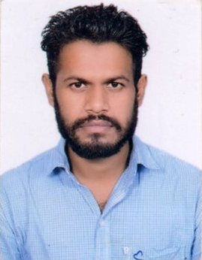
Curriculum Vitae
GURPREET
Mail ID : gurpreet.375828@2freemail.com
Mobile: Whatsapp +971504753686 / +919979971283

APPLIED FOR THE POSITION OF “ HEAVY VEHICLE DRIVER”

PROFILE:-
A Suitable position with an organization where I can utilize the best of my skills and abilities that fit of my education, skills and experience a place where can encourage and permitted to be an active participant as well vital contribute on development of the company.
WORK EXPERIENCE
- Working as “Heavy Truck Driver” in India from 3 years.
- 1 year worked in ARMAN BUILDING CLEANING SERVIES as outside building cleaner in UAE.

Skills:-
- Very energetic result oriented and organized
- Effeicient and well behaved person
- Extremely hardworking self motivated and able to work independently in a team environment under supervision
- Keep exelent inter personal relation with colleagues and ready to help them

LICENSE DETAIL
License No. Date of Issue : 01-11-2016
Position : Heavy vehicle (no.4) Date of Expiry : 31-10-2026
Place of Issue : AL FUJAIRAH ( UAE )

ACADEMIC QUALIFICATION
Diploma in Electronic communication engg.

PASSPORT DETAIL
Passport no. : M2518392 Date of Issue : 09-10-2014
Place of Issue : Amritsar Date of Expiry : 08-10-2024

PERSONAL DETAIL:-
Name : GURPREET
Date of birth : 12/03/1994
Nationality : Indian
Gender : Male
Religion : Sikh
Marital Status : Single
Language known : English, Punjabi & Hindi
Current Location : India

DECLARATION
I hereby certify that the above information are true and correct according to the best of my knowledge & My Experience. If selected I assure that I would perform to the best of my abilities. Early awaiting a positive response.
GURPREET

