PATRICK
Nationality: Indian
Mobile: Whatsapp +971504753686 / +919979971283
Email: Patrick.375830@2freemail.com

Versatile & high energy professional aiming for senior level assignments in Production & Quality Management/VendorManagement with an organization of high repute
- Offering rich business acumen & record of flawless service & achievements across a diverse range of functions

PROFILE SUMMARY

- A competent professional with 3 years ( 1 month UAE ) experience in:
~ Production Management ~ Vendor Management ~ Quality Assurance
~ 5S / TPM / TQM Implementation ~ ERP / Master Production Scheduling ~ Audit Works
- Well versed with FRP Moulding manufacturing methods and their applications.
- Trained with Infusion Moulding process also with Cost estimation and optimizing resources for this manufacturing process
- Proficient in Defect finding and analysing and effective counter measures
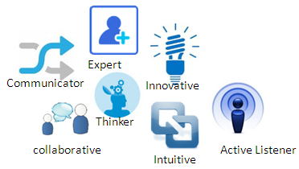
- Demonstrated abilities in new products in cast iron foundries, sheet metal pressed components and high precision machined
- Proficient in enhancing processing methods, optimizing resource & capacity utilization, improving productivity & operational efficiencies; while curtailing costs & expenses
- Adroit in managing sheet metal pressed components, sheet metal fabrication, castings, forgings and machined components
- Well versed with master production planning & scheduling, supplier fallow ups and ERP production
- An effective communicator with good interpersonal, analytical, negotiation and problem solving skills.

CORE COMPETENCIES

- Undertaking activities related to Defect checking and analyses of root cause and arresting the defect permanently by effective control methods and also Estimation of raw materials cost and other consumables
- Managing the Production schedules with teams to satisfy the end customers with zero defect parts
- Expertise in Sheet metal pressed parts, fabricated parts, Castings, forgings and high precision machined
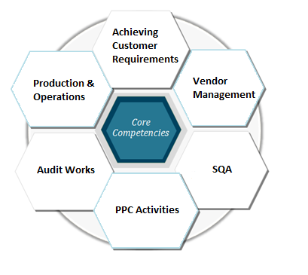

- Undertaking activities related to micro level activity planning for implementation of firewall at supplier’s end to achieve <100 PPM, planning and executing supplier wise quality improvement programs
- Undertaking activities related to tools, jigs and fixtures – design, material selection, production methods, procurement & adopting latest trends in the field

- Handling production related tasks i.e., controlling & troubleshooting for achieving the planned periodic schedules and process control
- Minimizing performance bottlenecks for high productivity with maximization of men, material and machine.
- Ensuring adherence to the quality standards; undertaking root cause analysis of problems and developing effective counter measures
- Appraising the prevalent production systems/ processes, identifying loopholes if any and undertaking result-oriented measures for alleviating them and documenting the same
- Identifying scope for planning / implementing cultural changes like TPM, Kaizen, etc. to enhance overall efficiency
- Performing micro level production scheduling using customized software & master data maintenance .

WORK EXPERIENCE

M/s Suvarna FibroTech Pvt Ltd, Vellore & UAE as Quality Assurance
Mar’17 – Oct’17 Engineer

Role:
- Responsible for:
- Quality inspection of FRP finished parts within Customers’s Specification and other Standards
- Incoming inspection of Raw materials i.e, Strand chopped Mat, Vinyl ester Resin and Bonding agents and documenting the reports
- Inspecting the Supplier’s fabricated child parts and fallow-up of respective third party test reports
- Daily monitoring of In-Process inspection at the time of Moulding and fitting process
- Documentation of all audit related files and records and maintaining on time basis
- Troubleshooting whenever the process deviates
- Analysing and Documenting the process line flow for Infusion Moulding Process i.e., Calculation of amount of raw materials used, process consumables, Cycle time for the process, Layer sequence
- Final Inspection of parts after assembling with the use of measurable gauges and fixtures to satisfy the Customer’s requirements with their standards.
- Analysing the Customer’s Part Drawings
- Handling activities related to:
- Physical inspection of FRP finished parts which includes Dimentional,Surface finish and damages like bubble,cracks,dents,shrinkage,delaminations,undulations etc
- Preparation of PDI reports
- Analysing and preparing CAPA & 8D reports based on Customer requirements. Also making effective problem solving techniques.
- Creating timely meeting with the subordinates for betterment of the Quality and Productivity
- Monitoring Kaizen activities on monthly basis and making other co-workers to participate in those activities
- Imparting training to moulders, fitters and finishers on customer specific requirements & problem solving techniques

Highlights:
- Promoted as Quality Engineer for UAE Plant- Supply of FRP bus body parts for M/S Ashok Leyland,UAE
- Merit of ensuring Timely supply of parts to the end customers with Zero Defects
- Certified with Infusion Moulding Process which also includes Cost estimation of raw materials and other consumables.

Oct ’15 – Feb’17 M/s ATV Precision Components Pvt Limited, Chennai As Production Engineer/Vendor Management
Role:
- Responsible for:
- Timely Delivery from RM to finished products with effective Production Schedule within realistic forecasts
- Produces the finished products within Customer’s Specification and other Standards
- Looking after entire supplier process to ensure zero safe launch issue
- Formulated yearly, quarterly & monthly production plan based on sales forecast
- Troubleshooting whenever the process deviates
- Working with ERP for accountability and process management
- Daily monitoring of Suppliers to attain Daily plan
- Handling activities related to:
- Planning and execution of Supplier Process Plans and fallow- up actions
- Coordinating with team members to Achieve the Targets and Deadlines
- Assigning duties and shifts for Junior staffs
- Looking after commodity wise supplier process to ensure trouble free supplies
- Imparting training to suppliers on customer specific requirements & problem solving techniques

Highlights:
- Process improvements in sheet metal major pressings – tooling, process modification, etc.
- Merit of ensuring more than 95% on time delivery month on month.

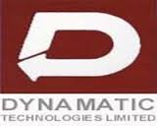

July’14-July’15 M/s, JKM Ferrotech Limited, Gummidipoondi (Dynamatic Technologies Group)
As Graduate Engineer Trainee – Production Department
Role:
- Responsible for:
- Completing the monthly schedule with zero rejections
- Creating Invoice for the customers once the components are ready for despatch
- Troubleshooting the process activities whenever some quality issues arises
- Management of supplier related activities especially for machining processes
- Scheduling plan for Shot Blasting process for the parts to meet the daily planned despatch
- Handling activities related to:
- Assigning works to machines operators and other workers according to the scheduled daily plan
- Maintaining production related documents for easy accessibility and also Audit purposes
- Looking after entire supplier process to ensure zero safe launch issue
- Up-keep of all direct & indirect machinery, equipment and instrument
- Creating Despatch invoice and DC’s using ERP software.

Highlights:
- Production Supervisor for :
- Daimler Commercial Vehicles Ltd- Supply of Bearing cast parts
- JKM dynamatics Ltd- Supply of Heat shields and manifold bearings cast parts

PREVIOUS EXPERIENCE

May’14-Jul’14: M/s Infosys Limited, Mysuru as System Engineer Trainee–JAVA & DBMS

Highlights:
- As a kick-start introduction to work culture, Infosys helped me learn new techniques
- Gave me the comfort zone to adapt to situation and problem solving capability
- Had an opportunity to get exposed and explore software related skills
- Taught me to work with a team in order to achieve greater outcomes
- Working with different people and their skills gave me the understanding of workflow process happening in a corporate in order to deliver a product as a whole .

DESIGN SOFTWARE SKILLS

- Worked with:
- AutoCAD
- CATIA
- MS Office Tools
- Presentations
- ERP Manufacturing

IT SKILLS

- Well versed with:
- Core JAVA
- Database
- HTML applications
- Other Internet Applications

EDUCATION

- Bachelor of Engineering in Mechanical Engineering from M/s SRM Valliammai Engineering College (Anna University Affiliated), Chennai with 67.50% in 2014 (first class)
- High School education in Computer science from Sunbeam matriculation school (TN State board),Vellore
with 93% in 2010 (First class)

PERSONAL DETAILS

Marital Status: Unmarried
Date of Birth: 20th October, 1992 (Age-25)
Languages Known: Tamil, English
Other languages: Hindi (Beginner)
Arabic (Beginner)

SIGNATURE WITH DATE

