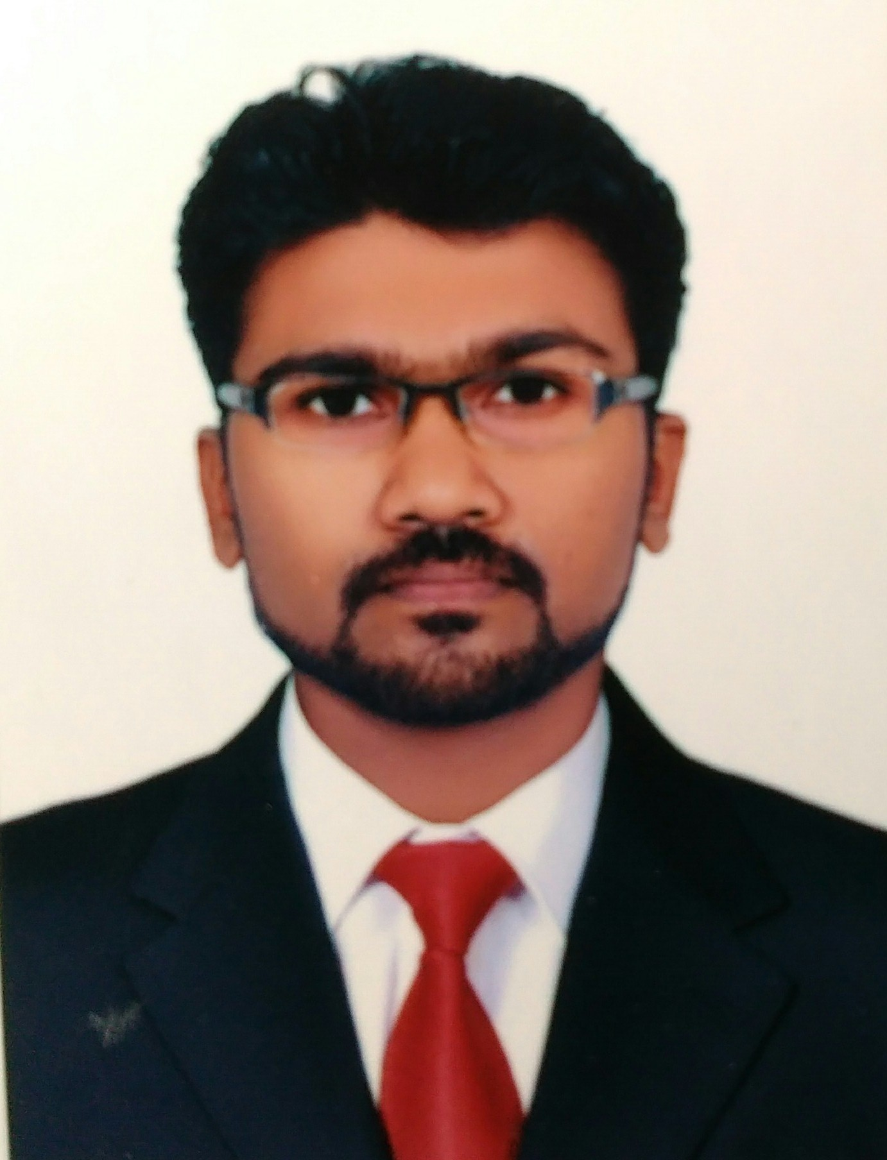
SHAMNAS

(MECHANICAL ENGINEER)

Shamans.375843@2freemail.com
Whatsapp +971504753686 / +919979971283

Objectives

To be an enthusiastic, successful, self-disciplined individual using my qualification and abilities to its maximum potential in your reputed concern and play a creative role for the company’s excellence. I would like to utilise the best of my creative & industrious abilities to enhance my career prospects and growth.

Experience

MECHANICAL PROJECT ENGINEER (4 Years )

Travancore hydrotech,
Panampally nagar, Cochin.
From AUGUST 2013 – SEPTEMPER 2017.

Responsibilities Handled
        - Prepare the tender /Architecture drawing /Shop drawing and material submittals for consultant approval.
        - In charge for overseeing all MEP works (mechanical, electrical and plumbing) and HVAC systems.
        - Ensure the MEP work carried out is as per approved shop drawing and within the time frame and progress of the approve construction program.
        - Ensure that installation, inspection and testing of all the MEP equipment , fittings and frame work implement meets the specification and consultant aprovements.
        - Coordinate with project personal to ensure the deadlines ,procedures and other project requirement.
        - Perform overall quality control of works and report regularly on project status.
        - Schedule work execution.
        - Coordinating all the sub vender and checking the quality of material .

        - Coordinating with other services like plumbing, fire and electrical work
        - Executing the project.

        - Preparation of drawings.

        - Heat Load calculation.
        - Quantity and cost estimation

        - Duct sizing and Pipe sizing.

        - Co-ordinate with sub contractors

        - Preparation of monthly reports for the project.

        - Time scheduling for the projects

        - Man power mobilization

        - Prepare and submit shop drawings for works

        - Supervision and Erection

Main Projects Handled

    - Hycinth Hotel Trivandrum

    - Marriott Hotel Trivandrum
    - Apollo Diamoro hotel Trivandrum

Education

ME –IN AERONAUTICAL ENGINEERING (JUL 2013)

NIET, COIMBATHORE

ANNA University, CHENNAI, TAMILNADU

B TECH - IN MECHANICAL ENGINEERING (JUL 2011)

SCT College of engg,Pappanamcode

Kerala University, Trivandrum, Kerala.

HIGHER SECONDARY EDUCATION

MBHSS Attingal, Kerala. State Board of kerala.

Personal Data

Date of Birth | : | 10th August 1988
Sex | : | Male
Marital status : |  | Married
Nationality | : | Indian
Languages | : | English,Malayalam,Tamil,Hindi

PASSPORT DETAILS

Place of Issue | : | Trivandrum
Date of Issue | : | 26/05/2010
Date of Expiry | : | 25/05/2020

Declaration

I hereby declare that the above furnished details are true to the best of my knowledge and belief.

Place : TRIVANDRUM SHAMNAS
Date : 05/12/2017

