Sami

Curriculum Vitae

Whatsapp +971504753686 / +919979971283
sami.375867@2freemail.com

Profile

I am passionate about new knowledge and I see an opportunity to develop in every challenge. I am confident in myself, my ambitions and I have a way of easily understanding people and creating new, trustworthy relationships.

”He who says he can and he who says he can't are both usually right”

Work experience

WSP | Parsons Brinckerhoff Västerås – Sweden Highway engineer 2016 -
- Road pavement analysis and design on major roads and highways
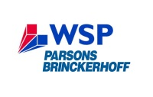
- Non-destructive pavement testing with FWD, GPD
- Material quality assessment through core sampling
- Assessment of road surface and road alignment conditions
- Traffic safety and its relationship to road design
Key words: pavement, FWD, GPR, back calculation, friction, rutting, IRI, road safety
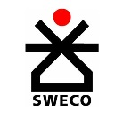
SWECO Västerås – Sweden
Road design engineer 2014 – 2016
- Road and highway design
- Planning and design of walk & bike paths, streets, parking lots etc
- University lecturer in road design
Key words: Civil 3D, Novapoint, Autocad, design, alignment, profile, cross section
Upgrades Education Stockholm – Sweden
Homework tutor 2012
- Homework tutor in mathematics, physics, chemistry
Key words: math, physics, chemistry, tutor

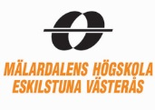
Mälardalens Student Sport Association Västerås – Sweden
Football leader 2010 – 2012
- Football leader and organizer
Key words: sports, football, university, leader

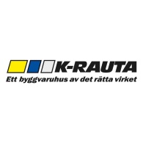
K-rauta store Stockholm – Sweden
Sales person 2011
- Sales person, in the construction section
Key words: sales, construction, building material

Master Thesis

Title: Road parameters and their influence on traffic accidents Stockholm – Sweden
Company: Sweco Civil 2013 – 2014
A case study on different road parameters and their influence on traffic safety.
By studying and isolating these parameters and their contributing role to the accident
occurrence, the aim is to explore their relationship and furthermore highlight the most
commonly associated with traffic accidents. This result is used to develop and
increase awareness of the impact of poor road alignment and poor road surface
conditions, in hope of reducing the number of deaths and injuries in traffic.
Key words: cross slope, curvature, IRI, rutting, drainage gradient, texture, side friction
url: https://www.diva-portal.org/smash/get/diva2:692740/FULLTEXT01.pdf

Academic achievements

Master of Science in Engineering Västerås – Sweden
Mälardalen University 2009 – 2014
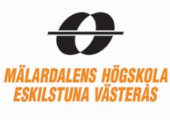
- Structural Engeneering
- AutoCAD, Revit, TEKLA
- Building Construction
- Soil Mechanics and Hydrogeology
- Structural design 2
- Master’s Thesis – Traffic safety
- etc..
The Hong Kong Polytechnic University Hong Kong
Department of Building Services Engineering 2013
- Design of Transport Infrastructure
- Architecture and buildings
- Sustainable Building
- Elementary Chinese
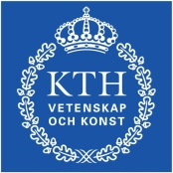
Royal Institute of Technology (KTH) Stockholm – Sweden
Infrastructure 2012
- Design of Steel Structures According to Eurocode 3
- Railway Traffic - Market and Planning
- Management and Maintenance of Traffic Channels

Courses
TEKLA Västerås – Sweden
Structures Basic Training Course 2011
- Three days course, earning a certificate

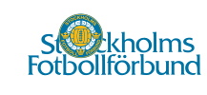
Stockholm Football Association Stockholm – Sweden
Football referee 2004
- Basic course

Skills and achievements

Language
- English – Fluent
- Swedish – Fluent (first language)
- Somali – Mother tongue
- Arabic – Basic (studying)
Computer
- Experienced MS-Office user
- Autocad
- Tekla Structures
- Revit 3D
- Novapoint
- Civil 3D
- PMS Object – pavement calculation program
- PVD – backcalculation program analyzing pavement structures
Care Africa International
A nonprofit family organization funding and working to improve road construction in Africa.
The project is called ’One dollar a month initiative’ and I hope to get more involved as times
passes.
Youth future association
Newly started association, facilitating and inspiring young people to achieve their goals, whether it be in school, driving license or in sports. Through homework tutoring, driving lessons, activities or jobcoaching, the idea is to provide a foundation for young people to be able to reach their maximal potentials.
Football
My greatest passion in life and it has really shaped me into the person I am. It has taught me discipline, cooperation, respect and so much more and I am still yet learning.

