CURRICULUM VITAE
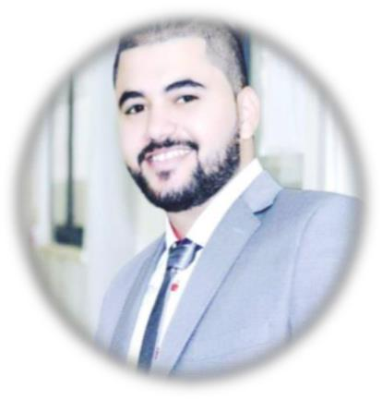

THAER
UAE / ABU DHABI

Mob: Whatsapp +971504753686 / +919979971283
E-mail: thaer.375881@2freemail.com

CAREER OBJECTIVE

“To apply my accounting experience to a role in project accounting, and further develop my skills across different accounting areas to maximize my expertise and efficiency in the position.”

Highlights

1 Quick learner and a very good team player.
2 Excellent analytical skills, a creative mind and a positive attitude.

3 Strong organizational skills with ability to work in high stress under deadlines.

4 Execute all entrusted tasks with precision and honesty and ever willing to shoulder any onsibility.
5 Excellent communication skills. .

6 The ability to deal with the accounting software excellently.

7 Meeting deadlines for the delivery of tasks.

8 The ability to manage time.

- Maintaining self-motivation continuously.
- The ability to apply to the public excellently.

EDUCATIONAL QUALIFICATIONS
✓ Bachelor's Degree Accounting from, AL-Hashemite University –2013-2017(Very Good)
✓ High School certificate (89% scientific section)

TECHNICAL QUALIFICATION
✓ A training certificate certified accountant qualification (36 hours)
✓ Accredited certificate in the analysis of financial statements
✓ Certified accountant qualification certificate equivalent 1 year of experience
✓ Certificate of King Abdullah II Bin Al-Hussein Fund in learning English

✓ I have good knowledge in Microsoft (windows, excel, word, PowerPoint, access) ✓ I have good knowledge in installing &working on windows XP professional ✓ I have good knowledge in hardware maintenance

Other skills
✓ Internet skills
✓ Language Arabic, English (reading, writing, conversation)

WORK EXPERIENCE
✓ Designation: Trained Accountant
  Organization: Prime Medical & Scientific Supplies (Amman, Jordan).
  Period: (Feb 2016 – Jul 2016) (during the study)
 
✓ Designation: Trained Accountant
  Organization: Audit Daar office. (Amman. Jordan)
  Period: (Aug 2016 – Dec 2016) (during the study)
 
✓ Designation: General Accountant
Organization: Dyaak Company for building materials. (Amman, Jordan)
  Period: (Jan2017 – April 2017)
 
✓ Designation: General Accountant
Organization: Alrawaiah Electronics and Electromicanical (UAE, ABU DHABI). 
  Period: (May 2017 – Until now)

- NOTE : I have a very good knowledge of VAT ( VALUE ADDED TAX) and I gave students lectures about VAT at university, and I can deal with it practically

PERSONAL DETAILS

Name: Thaer
Date of Birth: 1/05/1995

Place of Birth: Amman

Marital Status: Single

DECLARATION

I, Thaer, do to confess that the facts furnished above are correct and true to the best of my knowledge.

