CURRICULLUM VITAE
RAJESH
Mobile Number: Whatsapp +971504753686 / +919979971283
Email: rajesh.375896@2freemail.com

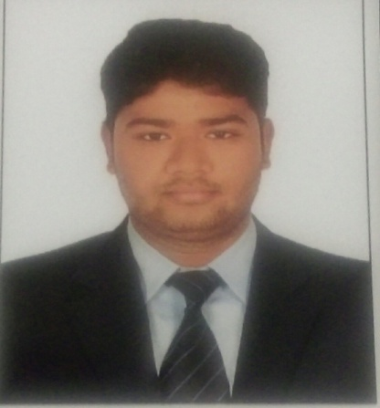

Career Objective
I wish to obtain a suitable position in an esteemed organization and wish to use all my constructive abilities and desirous to make my career by enhancing my quality of work as demand to achieve the desired result.
Work experience:
- Company : Etihad Airport Catering Services
- Position : Catering logistic Assistant
- Period : October 2014 to till date in Abu Dhabi ,UAE

- Company : Oberi Flight Services
- Position : Catering Supervisor
- Period : Two Years in Chennai India
Educational Qualification:
- BBA (Bachelor of Business Administration)Discontinued at the fifth Semester
- MS OFFICE Computer knowledge
Responsibilities:
- Loading/ unloading airline carts
- Sorting cutlery and crockery
- Stored food in designated containers and storage areas to prevent spoilage.
- Communicated with the kitchen team members to ensure food was prepared on time and correctly.
- Food delivery to the allotted sites
- Brief to Crews
- Tray setting and cleaning
- Immediately reporting accidents, injuries and unsafe work conditions to the managers
- Provided excellent customer service.
- Facilities control and management
Personal Skills:
- Possess good communication abilities and convincing skills.
- Problem solving at different levels of deportments strong organizational and time management,
- Very polite and helping nature.
- Good problem solving skills.
- Strong interpersonal
- Dynamic enthusiastic & Creative individual
- Able to work under pressure & meet Deadlines
- Self-confidence & friendly nature makes me adjust easily with different people and situation.
Personal Details:
Nationality : Indian
Date of Birth : 04-04-1993
Gender : Male
Marital status : Single
Religion : Christian
Visa status : Employment (Transferable)
Language : Tamil, English, Malayalam, Hindi.

Declaration :
I hereby declare that the above given information is true, correct and complete to the best of my knowledge and belief.

