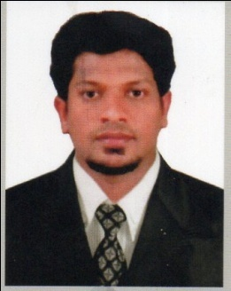  SUJAI  Email id :  Sujai.375911@2freemail.com  Contact No :  +971504753686 / +919979971283  Personal Details :  Date of Birth : 05/06/1986  Sex : Male  Nationality : Indian  Marital Status : Single  Religion : Hindu  Health : Good  PASSPORT DETAILS  Place of Issue : Kozhikode  Date of Issue : 01-10-2013  Date of Expiry : 30-09-2023  DRIVING DETAILS  Place of Issue: Kannur  Date of Issue : 01-07-2014  Date of Expiry: 30-06-2034  Class of Vehicle  - M/c with gr  - LMV  Language Proficiency :  English :  Speak, Read & Write  Malayalam :  Speak, Read & Write  Hindi :  Speak, Read & Write  Tamil :  Speak  Kannada:  Speak  Software Skills :  - Operating Systems : Windows XP 7,8  - Fundamentals : MS Office  - CAD  Hobbies :  - Travelling  - Driving  - Cricket  - Football | CURRICULUM VITAE  Career Objective  To work in a challenging organization with a stimulating environment where I can keep learning and apply my inherent skills and knowledge aligning my career goals to that of the organization.  Career Portfolio  - Strong decision making.  - Problem solving abilities.  - Quick learning capabilities.  - Strong oral & written communication skills.  - Hard working.  - Dedicated to whatever I do.  Career Summary  - After completing the engineering graduation in Mechanical Engineering, I worked as Mechanical Maintenance Trainee Engineer at Sthapathy Builders, Pallikunnu, Kannur, Kerala. (From 28th Jan 2013 to 30th Nov 2015)  Highlights of my professional career include the following :  - Maintenance of all constrection Machineries .  - Supervising Labours & Machineries  - Worked as Mechanical Maintenance Engineer in CAR LAND.(23rd Dec 2015 to 30th Sept 2017)  - Maintenance and Supervising  - Customer handling  Academic Profile  - Bachelor of Technology (Mechanical Engineering course) from Adichunchanagiri Institute Of Technology Chikmagalur , VTU University, Karnataka, (Batch : 2007-2013)  - HSE from SN Trust HSS, Kannur, Kerala with: 58%.  - SSLC from Chovva HSS, Kannur, Kerala with: 58%.  Project Experience  - Main Project : ” Machine Vision Based Automatic Testing”-  - Mini Project : “ Modern Robotic Surgery “  Declaration  I hereby declare that all the information given above are true and correct to the best of my knowledge and belief.  Place : Kannur Yours Faithfully  Date :  SUJAI

