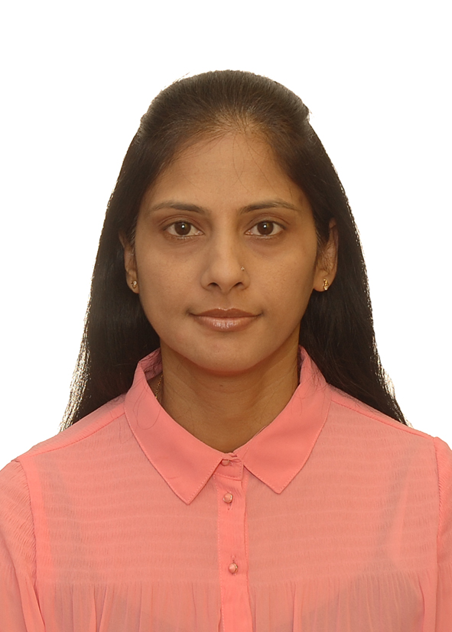
SANDHYA
Contact: sandhya.375939@2freemail.com / Mob: Whatsapp +971504753686 / +919979971283
Nationality:Canadian
Languages: English and French
teacher with eyfs experience
Profile
5 years of experience as Teacher in UAE at the Teddy Bear American Nursery and Future International Nursery.
3 years of Experience in Accounting at BelCourt Properties, Montreal, Canada
Responsible, organized, dynamic, creative, resourceful and reliable.
Able to work effectively in a team and under pressure.
Fields of Competence
Early Years sector
- Good knowledge of the EYFS Curriculum.
- Working with babies (age group 8 mths-24 mths) and children (age range 2 to 4 years old).
- Be able to lead a group of young children and their parents through different activities.
- Knowledge and skills to face new challenges.
- Team player and able to manage a classroom team.
- Ensure that children are comfortable, safe and having fun in their environment.
- Ability to communicate well with parents.
- Build positive relationship with coworkers, parents and children.
- Good written and interpersonal skills.
- Ability to manage many tasks quickly and efficiently.
- Fluent in English and French.
Accounting - Accounts payable
- Calculate, prepare and emit documents associated to accounting such as bills, inventory, statement of accounts and other financial statement. Keep payroll records
Computer Knowledge
- MS Office, Word, Excel, Access, Acomba and outlook.
CAREER HISTORY
2016- Dec 2017 Teacher Future International Nursery, Sharjah (United Arab Emirates)
2015/10-2015/11 Teacher British International School Ajman (United Arab Emirates)
2014-2015 Teacher Teddy Bear American Nursery, Abu-Dhabi (United Arab Emirates)
2011-2014 Accounting Technician Belcourt Properties Inc., Montreal, (Canada)
2008-2010 Assistant Teacher Teddy Bear American Nursery, Abu-Dhabi (United Arab Emirates)
2002-2207 Assistant Finance Officer Ministry of Finance, (Mauritius, Port-Louis)
1992-2002 Accounts Clerk Ministry of Health, (Mauritius, Port-Louis)
Education
2014-2015 Level 3 Diploma for Early Years Educator (EYFS Curriculum) City and Guilds, (UK)

2010-2011 Diploma in Computerized Accounting System O’Sullivan College of Montreal
1989 -1990 Cambridge Higher School Certificate Loreto Convent, (Mauritius, Port-Louis)
1982-1988 Cambridge School Certificate Loreto Convent, (Mauritius, Port-Louis)
Professional Development Training
27 Apr 2015 Learning the Montessori way – Quality Matters 4 – Children - UAE
17 Jan 2015 First Aid Course – First Aid International – UAE
02 Feb 2015 Scientific Inquiry Heuristic Play – Quality Matters 4 – Children - UAE
04 Nov 2014 Protecting Children in the UAE – Quality Matters 4 – Children - UAE
Jan – Dec 2008 Oracle certificate - Galaxy Computer Education & Training Institute (Abu-Dhabi, UAE)
Jan – Dec 2008 Certificate Computerized Accounting System (Bookkeeping, Accounting, Tally, Peachtree, Quick book)

