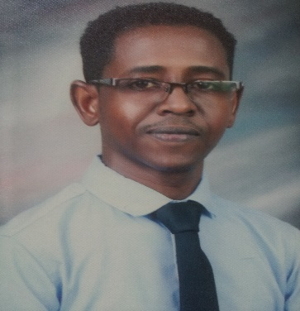
(C.V) Curriculum Viate

Personal Information:
Name: Basher
Nationality: Sudanese.
Place & Date Birth: Khartoum- Sudan - 1981
Address: Abu Dhabi-UAE
Contact number: Whatsapp +971504753686 / +919979971283
Email: basher.375942@2freemail.com
Qualifications:
- Bachelor of Science in Civil Engineering-Lyceum -Northwestern University-April-2017.
- Diploma (Three years) in Civil Engineering-Khartoum College Technology-March-2005.

Additional Courses:
- Loss control management (Advanced Occupational Safety and Health).
- Business Processing Outsourcing Certificate (BPO)- 270 hours , 15 units of BPO subjects.

Experiences:
- Greater Nile petroleum Operations Co at construction section as civil engineer- December-2011 to December -2014.
- Gulf Engineering House at Highways Sanitary Drainage as foreman- February-2010 to march-2011- Riyadh – Saudi Arabia.
- Lulu palace International for Trade & Contracting company- April-2005 to August-2007.

Languages:
Arabic (Mother Tongue).
English.

Skills:
* Good computer skills include MS Office applications.
* Ability to prioritize and plan effectively.
* Flexible and willing to travel.
* Ensuring confidentiality at all times.
* Able to communicate effectively both verbally and writing in English and Arabic language.
* Ability to work in team and individually under minimum supervision as well ability to take initiative.
* Highly motivated- head working and efficient
* Ability to work under any pressure.

Other:
- Sudanese Driving License.
- Saudi Arabia Driving License.

