 |  | IRFAN |  |  |  | VISA STATUS :- | VISIT VISA
 |  | S E C U R I T Y S Y S T E M E N G I N E E R |  |  |  | NOVEMBER 2017 --- 1 FEB 2018
 |  | E-Mail id :- irfan.375960@2freemail.com |  |  |  | 971504753686 |  | ( UAE )
 |  |  |  |  |  | 919979971283 |  | ( IND )
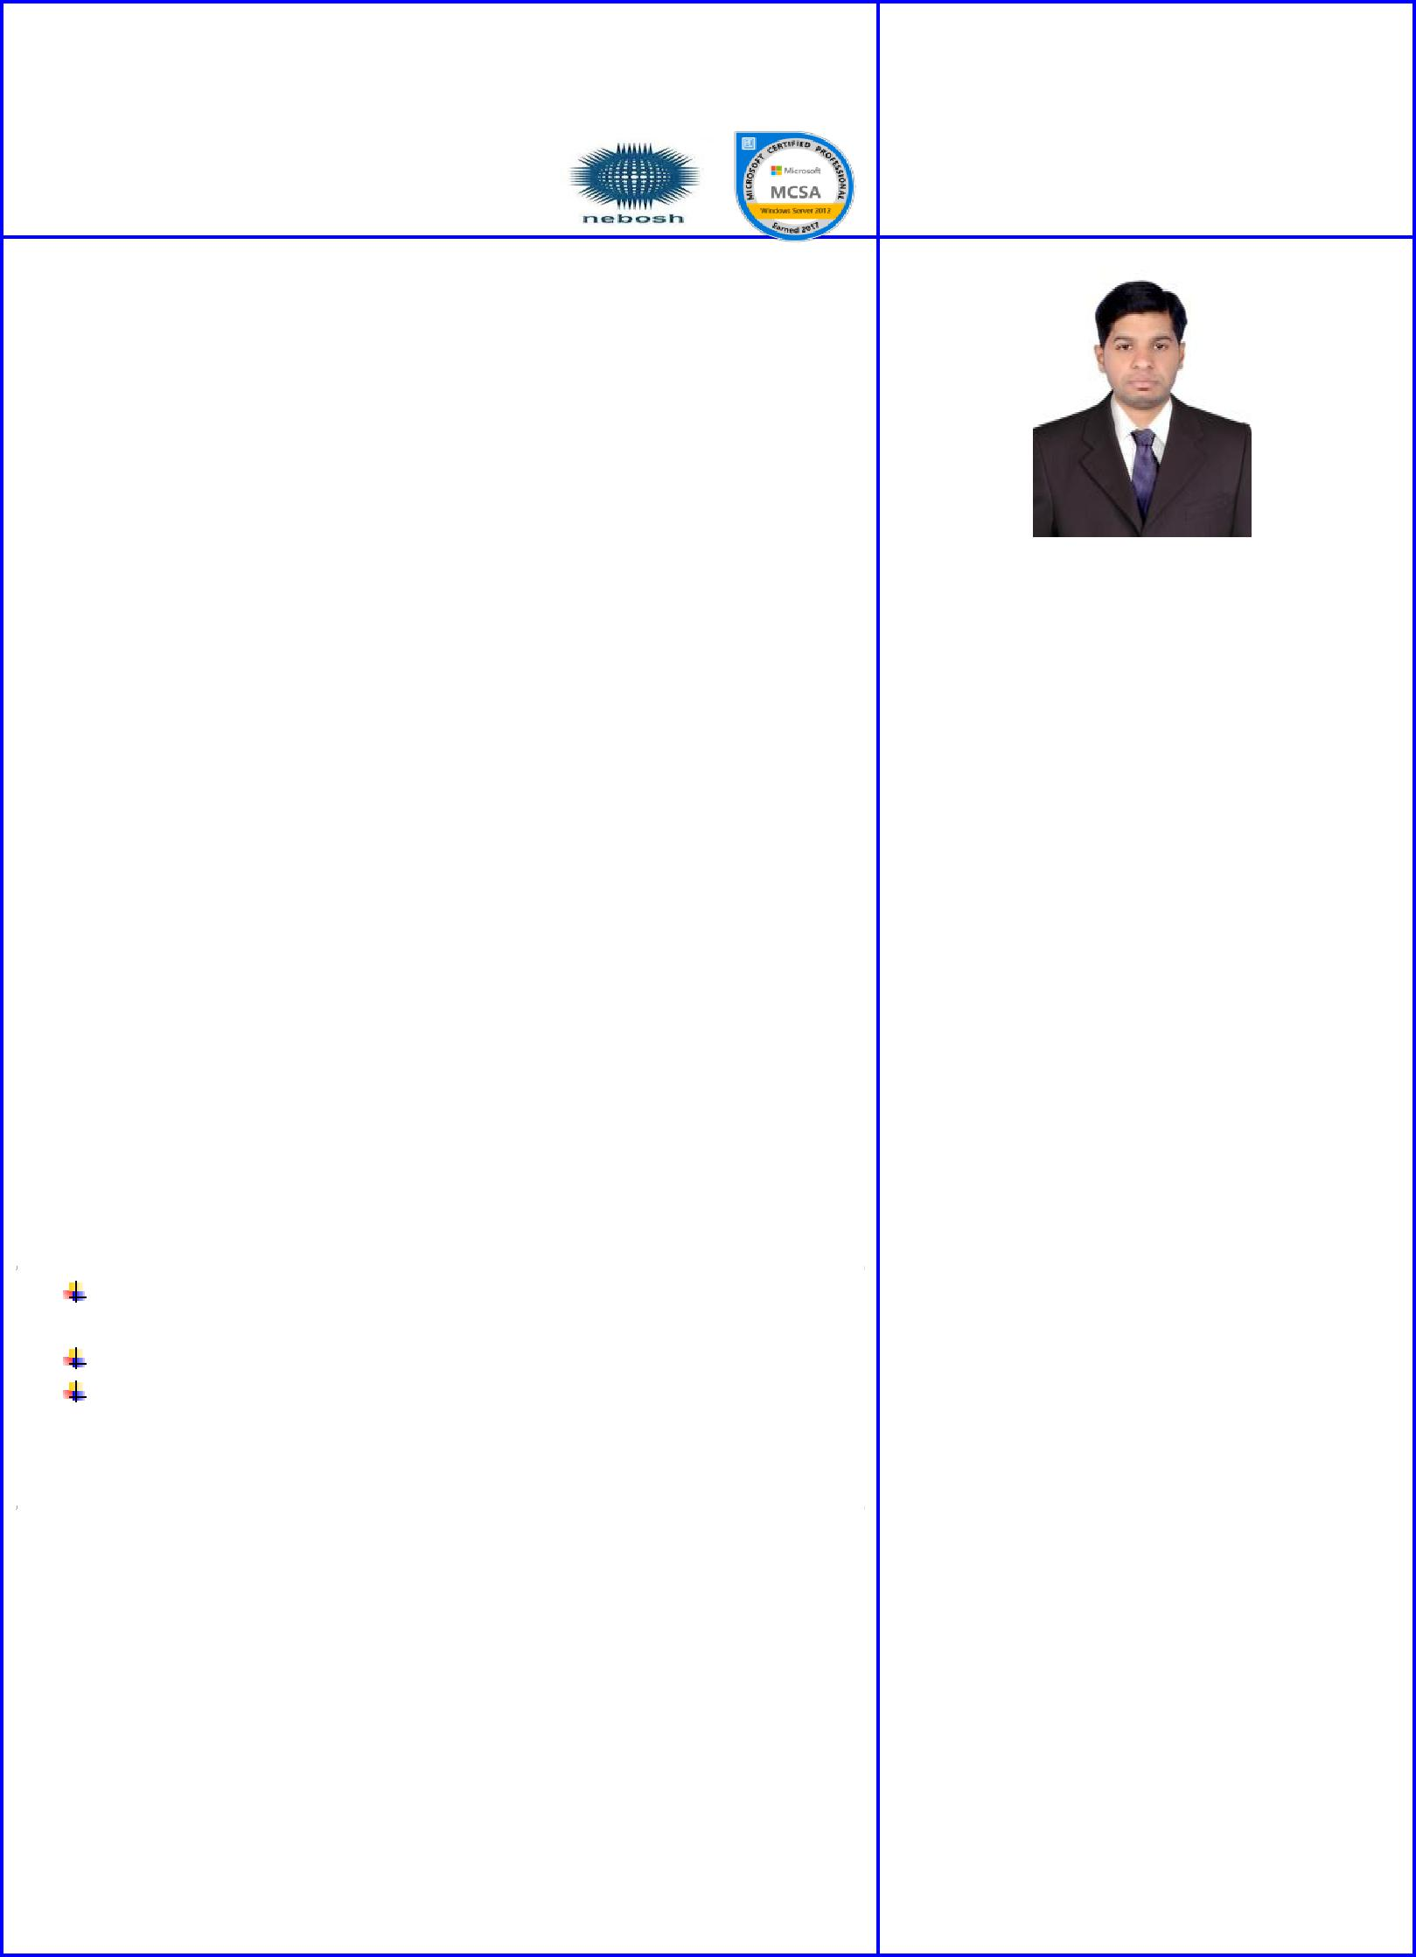
 | OBJECTIVE
A Qualified Security system engineer with a very good experience in
CCTV and Access Control projects design, implementation and
coordinator, with hand on experience in CCTV,ACS, software testing
and IT including Microsoft windows servers and cisco networks seeking
a job where I can use my knowledge and experience to integrate IT &
security systems components and to get more experience in low current |  |  | Nationality | : Indian
systems & networking field.
 |  |  | Date of Birth | :11.08.1992
 | Professional Abridgement |  | Marrital Status : Single
 |  |  | Passport Number : M 2345468
➢ | Exposed to Single line diagrams for low voltage layout of cable |  | Place of Issue | : Hyderabad
 |  |  | Date of Issue | : 23-09-2014
 | routing feeder, racks etc.
➢ Have experience in configuration of POE Cameras (Analog and |  | Father’s Name: MD Akther Ahmed
 | IP Based Cameras), Encoders, Optical Video Transmitters, &
 | Receivers. |  | Strengths
➢ Prepare and maintain daily work reports. |  | ▪ | Team builder
➢ Coordinating with client, consultant and project management
 | team for smooth execution of project. | ▪ | Network
- Excellent problem solving, analytical and logical thinking skills.▪ _{Confident}
➢ The ability to learn new things in short time. |  | ▪ |  | Very creative
➢ Conducting training sessions (internal & External).
 |  | ▪ |  | Project Presentations
Education:-
 |  |  |  | Technical Skills
 |  | ▪ |  | Operating Systems:
B.TECH in Electronic and Communication April (2010-
2014)from JNT University Hyderabad, India. |  |  |  | Windows
Board of Intermediate Education, Hyderabad, (A.P.) (2010). |  |  |  | 98/2000/XP/Vista/Win8 and
Board of Secondary Education, Hyderabad, (A.P) (2008). |  |  |  | Win10
Technical Skills:- |  | ▪ |  | Server Platform:
 |  |  |  | Windows Server 2008/2012
 |  | ▪ |  | Languages:
❖ IPCCTV,VA, Access control system, Public addressing and
voice evacuation systems. |  |  |  | C, C++, Java
❖ Window , Linux and Network Administration |  | ▪ |  | Office tools:
❖ Software Testing (QTP/UFT)
 |  |  |  | MS Office 2003/2010
❖ Worked with various PLC technologies and develop and update
 |  | ▪ |  | Courses:
existing code for the equipments.
❖ Control Panel (Power wiring & Control wiring). |  |  |  | ❖ SoftwareTesting(QTP/UFT).
❖ Dell, HP Server Win2K8, 2012 and SQL 2K8, 2012 with
 |  |  |  | ❖ Telecom Protocol Testing.
domain services
❖ Testing & Commissioning. |  |  |  | ❖ PLC SCADA HMI.
❖ Diploma in Fire and Safety from Omega Institute Hyderabad. |  |  |  | ❖ Security System (BMS).

Accomplishments

I am a skilled professional with over 3 year’s commercial experience. I have been involved in various project over the years including installation, configuration and commissioning testing of integrated building management systems including CCTV, Access control security systems.

Professional Experience Electronic Site Engineer
November 2015 to August 2017
Arcus Automation Private Limited @ DLF Building, Hi-Tech

City, Hyderabad.

- Installation and configuration of CCTV/Remote. Surveillance Systems.

- Installation and configuration of Intruder Alarm System.

- Providing solutions/proposals to the client as per their requirements related to Close Circuit TV &other Security related systems.

- The design of the low current system and reviewing AutoCAD drawings.

- Coordinating with all the parties at site for the completion of work and solving work related issue.

- Giving prompt and effective attention to emergency call received during and after work hours.

- Worked with access control system card reader, long range card reader, push to exit button, magnetic lock, strike lock, biometric reader and door contact.

System Engineer
September 2014 to August 2015

Arcus Solution Private Limited @ DLF Building, Hi-Tech City, Hyderabad.

- Install, upgrade, support and troubleshoot of Microsoft windows in workgroup and Domain Models.

- Supporting Installation and troubleshooting all Security Systems installed by the Company.

- Installation and configuration of Microsoft Windows in Workgroup and Domain Models.

- Installation of DNS, DHCP.FTP.IIS and server.

- DFS management and user rights assessment.

- Installation and configuration of various network printer and giving users access to it.

- Implemented and managed IP Addressing, configured TCP/IP addressing on a server.

- Taking regular backups and restoring it as and when required.

- Configuration of Layer 2 Cisco Catalyst switches for VLAN

- Managing and creating Users Profiles, User Rights and Groups and OU’s.

- Resetting user account passwords and releasing the user account locks.

- Handling computer networking, hardware, software related problem solving, and network trouble shooting.

- Configuring and managing cluster solution.

Languages Known

English: Proficient

Telugu: Proficient

Hindi: Proficient

Urdu: Intermediate

SkillSet
- Team building and leadership qualities.

- Interpersonal and conflict management skills.

- Ability to deal with people diplomatically.

  - Multi Tasking

- Comprehensive problem solving abilities.

Interesting Areas
- Industrial Automation Projects

- Power Plant Projects.

- Power Electronic.

Personal strengths:

- Good amount of work experience Security & System Engineer

- Ability to work on assignments and accomplish it.

- Good at handling in tough situations.

Certifications:-

Microsoft Certified Solution Associate (MCSA)
Microsoft certification Id (14421610).

NEBOSH Award in Health & Safety at Work (00381363/927430).

NEBOSH (UK).

Certificate Training courses :-

CCTV,ACS,FAS,Intercom ,PLC ,Software testing tools, Telecom protocol testing, CCNA,MCSA, Linux and Networking,Fire and Safety.

Declaration:

I declare that all the information stated above is true to the best of my knowledge.

HOBBIES: -
- Lesi ni n g son gs .

- R eadi ng i sl am i c boo k

- W at chi ng vi di o .

Date: Thanks & Regards,

Place: Irfan.

