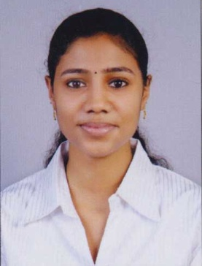Animol
Email : animol.375997@2freemail.com
Contact No: Whatsapp +971504753686 / +919979971283

CAREER OBJECTIVE:

Seeking a career to utilize my knowledge, personal skills to gain comprehensive understanding of a reputed organization so as to take responsibility and i can communicate with the people and that should help the organization to achieve their goal.

PROFILE SUMMARY:
- A dynamic and multitalented professional with exceptional financial and HR knowledge having degree of MBA.
- Excellent in identifying the need of organization.
- Excellent in understanding and analyzing the human behaviour.
- Excellent in utilization of all resources.
- Experience in financial aspects and policy for business aspect.

PERSONAL QUALITIES:
- Strong leadership and motivational skills.
- Exceptional presentation and interpersonal skills.
- Ability to handle pressure.
- Excellent in communication in written and verbal both.
- Ability to work in a team as well as individual.

ACADEMIA:
- Pursued Tally Course in Tally Academy Kerala.
- Pursued MBA in Finance and HR from Noida International University, Greater Noida (Delhi).
- Pursued BCA from Santhigiri College of computer science (Affiliated to Mahatma Gandhi University) Kerala.
- Passed Higher Secondary from St. Augustian’s Higher Secondary School Kerala.
- Passed SSLC from Little Flower High School Kerala.

PROJECTS:

Project Name 1: Cash Management
Project Area : Finance
Company : District Corporative Bank, Kottayam
Duration : 2 months

Project Name 2: HR Policy and its implementation
Project Area : Human Resource
Project Title : Research work
Duration : 1.5 Months

COMUPUTER KNOWLEDGE:
- Knowledge in MS Office Word, Power Point.
- Operating system Windows XP, Windows 7 and Windows 8.

EXTRA CIRICULAR ACTIVITY:
- Attended international conference "The Tiger” conducted by college.
- Coordinator of woman’s safety in college.
- Active in coordinator of cultural activities in college.
- Attended work shop “Perfect Management” in college.

EXPERIENCE:

- Currently working in Mariya Mart (Since June 1st ).

PERSONAL DETAILS:

Date of Birth - 15th March 1994
Languages Known - English, Malayalam, Hindi
Nationality - Indian

