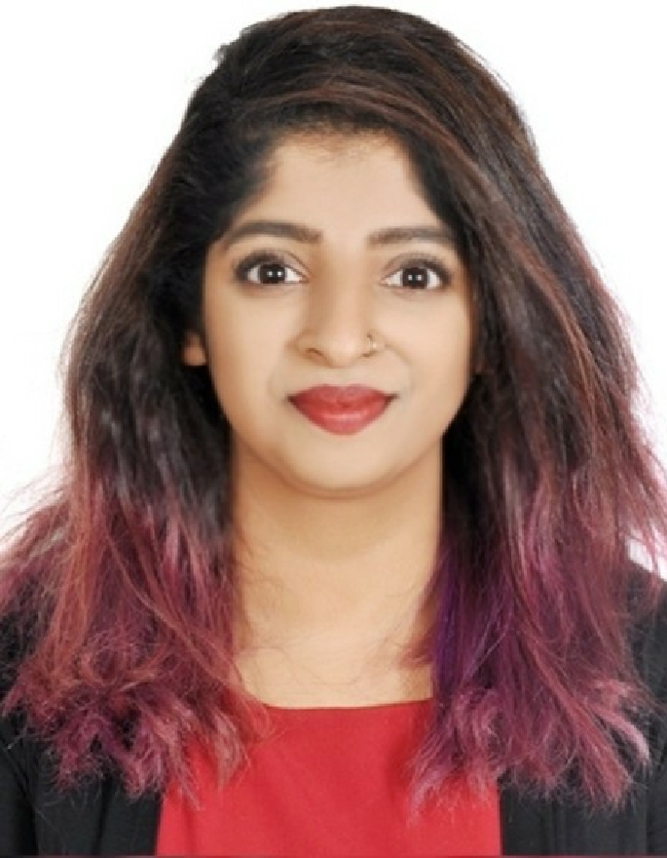
Pratika
Executive Sales Consultant

Summary

2017-07 -
2017-11
Executive Sales Consultant with experience specializing in IT Sales. I have demonstrated strong
skills in building relationships with clients. My interest is to strive for continued excellence with the
use of my communication and sales skills. My current goal is to transfer what I have learned to an
area that is my passion: Marketing Management/Hotel Management/Event Management.

Experience

Executive Sales Consultant - SAP
SHARAF DG - Dubai

Personal Info

Phone
Whatsapp +971504753686 / +919979971283

mail

pratika.376008@2freemail.com

  - Supported all pre-sales activities of the company.
  - Actively sought out new sales opportunities through cold calling and networking.
  - Developed effective sales plans.
  - Determined a client's business requirements and whether the software being considered is suitable.
  - Demonstrated how the software works and provided detailed technical specifications and advice to customers about installation and usage and presented software presentation with objective of increasing customer interest.
  - Decided whether the software requires add ons or additional implementation to meet the requirements of the client.
  - Presented findings to a technical team to act on, and then to the client.
  - Participated in team meetings to discuss progress, plans, and other activities.
  - Ensured all problems and issues are reported to manager.
  - Addressed concerns of customers by providing clear instructions and solutions.
  - Prepared proposals and reports.
  - Enabled customers to maximize use of software by providing proper user training.
Skills
Excellent selling skills

Initiative

Persuasive communicator

Motivated seller

Ability to write reports and proposals

Efficient

The capacity to work well on my own or in a team

Multi-tasker

2017-03 -
2017-05

Sales Executive - Microsoft
REDINGTON GULF - Dubai

Negotiating skills

  - Expanded client base through cold calling to qualified prospective customers.
  - Planned and organized the day to ensure all opportunities are maximized.
  - Dealt with customer enquiries face to face, over the phone or via email.
  - Managed the sales process for new prospects, from initial contact through to closure.
  - Contacted prospective customers and discussed their requirements.
  - Developed a full understanding of the business market-place.

The ability to manage time and plan the day effectively

2017-01 -
2017-03

Customer Relationship Executive
AVANCE AUTO SERVICES LLC - Dubai

Languages

  - Communicated courteously with customers.
  - Followed up the service calls for vehicle services and customer satisfaction service.
  - Achieved company target of follow up vehicles for service.
  - Unique ability to stay on top of Customers issues, deliverables and escalations for customer satisfactions to ensure the timely resolution of issues.
  - Handled CR Dept. – data providing for CRE's for Service Reminders Calling.
  - Managed Complete Operations – starting from vehicle check to preparation of Invoices (till delivery of vehicles to the Customer).
  - Prepared Monthly Vehicle Inflow Reports.
English

Hindi

1998-04 -
2008-05

2008-04 -
2010-05

2011-04 -
2014-05

Education

Our Own English High School - Dubai
Primary & Secondary Education

Holy Trinity School - India
Higher Education

Dr.G.R.Damodaran College of Science - India
  - OM WITH COMPUTER APPLICATIONS

2014-02 -
2014-03

Additional Activities

Malabar Cements Limited, Kerala, India
Project: Organizational Study

    - To study about the structure of the company
    - To create a financial report.

Interests

Dance & Music Reading & Cooking Trekking & Riding Bowling

