c.v
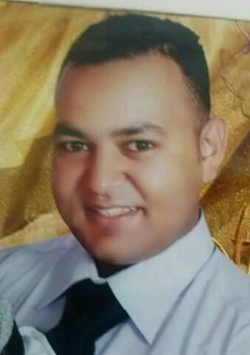
Personal data:
NAME : Ahmed
Date of birth :15/6/1982
Age :35 years' old
Gender : male
Nationality : Egyptian
marital status : married with 3 children
military service : excused
religion : Muslim
visa type : tourist visa for 3 months from 1/12/2017
I have Egyptian driver’s license
Address : Dubai
email address : ahmed.376037@2freemail.com
phone number : Whatsapp +971504753686 / +919979971283
work purpose:
My objective is to work with a reputable organization, professional management team, and healthy working environment in order to share my experience, a achieve our objectives and succeed to getter
and I hope to do so much with my new job, so that
When I gets the chance I will make sure to seize it, and I have huge hopes to a chive my goals and ambitions with your respected company.
Education:
Bachelor of commerce – accounting section
Class of 2004. grade (good)
Languages:
Arabic: mother tongue. English: good right and talk
Computer skills:
- Quick books (very good)
- sage 50 (excellent)
- peach three(excellent)
- Word (very good)
- accounting excel(excellent)
- internet (very good)
Personal skills and qualification:
Expressing option - patience - good futuristic look –making decisions and team work spirit
Working under pressure for the long time.
Previous work experience :
- 1-From march 2011 to November 2016, worked for Al_Ghonaimy company in trading in cement and steel, did accounting, Incharge of the customer's movement, collecting money, customers follow up and delayed payments printing weekly reports and delivering it to the management
- After two years' I was transferred to the cement division, working for the management and crisis solutions and dealing with tough situations whether with employees, drivers, or customers.
- 2-from august 2009 to January 2011 worked for Balba , village for Grilled food , in charge of the cashier and also the accounts of the suppliers and organizing daily book keeping.
- 4-from January 2008 to march 2009 worked for "Namaa" real –state company, in charge of subcontracts and construction engineers, ceramic contractors.
- 5-from June 2005 to November 2007, worked for Egyptian mail circulation, book keeping
- And client management also daily with draw it and deposit processes qualified in calculating annual profits.

