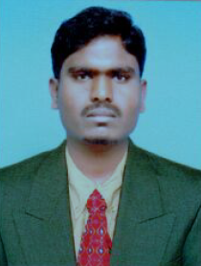
CURRICULUM VITAE

Mr. Yashin
Mobile No: Whatsapp +971504753686 / +919979971283
E-mail: yashin.376041@2freemail.com

OBJECTIVE

Seeking a position to utilize my skills and abilities in the information technology industry that offers professional growth while being resourceful, innovative and flexible.

PROFESSIONAL EXPERIENCE: “FITTER TECHNICIANS”

Bill ForgeePvt Ltd., Bangalore – 4 Years of Experience
- Designation : Production Milling Machinist Technician
And General Fitter Technician
- Duration : 2013 to 2016

EDUCATIONAL QUALIFICATION:
- S.S.L.C.
- I.T.I (Fitter)

PASSPORT DETAILS:
- Place of Issue : Bengaluru, Karnataka, India
- Date of Issue : 10/04/2017
- Date of Expiry : 09/04/2027

VISA STATUS : 3 months Visit Visa

PERSONAL PROFILE

- Date of Birth : 23/11/1993
- Place of Birth : Nidagundi (Karnataka)
- Nationality : Indian
- Marital Status : Unmarried
- Languages Known : English, Hindi, Kannada & Arabic

DECLARATION
I do hereby declare that all the above-mentioned information are true and correct to the best of my knowledge.

Place: DUBAI
Date: (Mr. Yashin )

