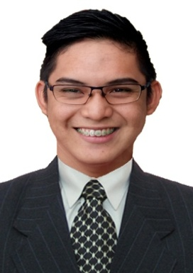
RUSSELL
Mobile: Whatsapp +971504753686 / +919979971283
Email Address: russell.376042@2freemail.com

OBJECTIVE:
I am seeking employment with a company where I can use my talents and skills to grow and expand the company.

QUALIFICATIONS:
- A working Knowledge of inventory and stack rotation.
- An ability to place orders.
- Skilled in leadership roles.
- Knowledge in Basic Microsoft operations (word, excel, and power point.)

WORK EXPERIENCE:
- TEASPOON CAFÉ
- January 2016-February 2017 (Cutcut Angeles City, Philippines)
- Position: waiter, barista
Waiter:
- Assist costumers taking orders and serving food and beverages in there table
- maintain standard quality service and cleanliness in the restaurant
Barista:
- preparing drinks in standard procedure
- maintain a clean sanitary work environment
- handle multiple tasks at one time
- work successfully as part of a team while under pressure.

- BERONG IKAZAYA
- December 2015 – January 2016 (Balibago Angeles City, Philippines)
- Position: kitchen staff

Duties and Responsibilities:
- Helping the chef in preparing /cooking of any kitchen works.
- Cleaning up the food preparation areas and equipment.

- THE BURGER SHACK CAFÉ
- March 2014 – February 2015 (Angeles City Pampanga, Philippines)
- Position: Kitchen Staff and Waiter

Kitchen Staff:
- Responsible for working with manager and chef of the kitchen in the preparation of meal and snacks.
- Also provides support to other staff members.
- Keep the working area clean and neat.
- Keep up with increasing customer demands.
- Responsible for receiving rotation stock and incoming orders.
- Responsible for performing other duties as assigned.
Waiter:
- Assist costumers taking orders and serving food and beverages in there table
- maintain standard quality service and cleanliness in the restaurant

EDUCATIONAL ATTAINMENT:
PRIMARY
Buenavista Elementary School
Buenavista Mexico Pampanga, Philippines
2007-2008

SECONDARY
Arayat National High School
Arenas Arayat Pampanga, Philippines
2008-2012

PERSONAL DETAILS:
Date of Birth : October 2, 1996
Civil Status : Single
Nationality : Filipino
Religion : Catholic
Visa Status : Tourist Visa (12/10/17-03/ 09/18)

I hereby certify that the above information is true and correct to the best of my knowledge and belief.

