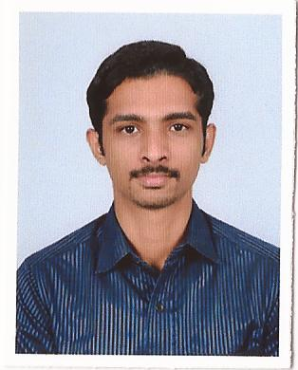
SARATH
Place: Dubai international city
Mob. Phone: Whatsapp +971504753686 / +919979971283
E-mail: sarath.376048@2freemail.com

`
PROFILE AT A GLANCE

A dynamic, highly motivated and result driven engineering professional offering more than 4years of work experience in HVAC field.

Seeking challenging job assignments in a good reputed firm where I can utilize my technical and management skills for continued development and success of the firm.
EDUCATIONAL CREDENTIALS

- Bachelors Degree in Technology-
Electrical & Electronics Engineering,
Lourdes matha college, Trivandrum,
Kerala University (2012)

TRAINING HISTORY
- Completed REVIT training at ICAD, Banglore

PERSONAL PARTICULARS

- Date of Birth: 27th April 1990

- Language Proficiency:
English, Hindi, Malayalam
- Nationality: Indian
- Marital Status: Single

- Passport
Validity- 08/08/2022.
- License: Indian Driving license

KEY ATTRIBUTES

- A productive individual with extraordinary work habits and commitment to ensure job completion in a cost effective & timely manner.
- Commitment and dedication to effectively achieve organizational goals and objectives.
- A resourceful, innovative and result oriented professional, possessing quick decision-making abilities and leadership qualities, to work efficiently in demanding work environments & meet deadlines.
- Prowess in overseeing various types of job and resolving bottlenecks.
- High competency with sound technical knowledge
- Possess excellent judgment and basic integrity in time management.
- Deft in relationship management, with sincere belief in initiative driven, creative & imaginative work culture.
- Ability to initiate effective cost management & efficient resource utilization steps for increased productivity.

EDUCATIONAL QUALIFICATIONS

Degree/Course | College/University | Passed in | Marks
Bachelor of Technology in  Electrical & Electronics Engineering | Lourdes matha college of Engineering, Trivandrum, India  University of Kerala | 2012 | CGPA – 6.6
Higher Secondary | St Joseph’s HSS, Trivandrum, Kerala, India | 2008 | 91 %
Senior Secondary | Vidhyadiraja Vidhyamandir, Trivandrum, Kerala, India | 2006 | 92%

CAREER MILESTONES

Role | Site Engineer(BLUESTAR) Jan 2013 to May 2017
Responsibilities | - Studying the work plan submitted by the contactor and suggest any modifications.  - To watch and inspect the construction work and assure that it is done in full accordance with the drawings, technical specifications and bills of quantities.  - Supervising the works on site in accordance with the contract documents and using the template and procedure established by the consultant.  - Inspecting and testing materials prior to their use at site as per sample approved by the consultant and ensuring removal of rejected material out from site.  - Ensuring the correct implementation of the works according to technical specifications, to designs and quality of materials

SKILL SETS
Software skills
- Microsoft Office
- REVIT Hvac
Management skills
- Good Communication and Presentation skills.
- Target Oriented and self driven.
- Self motivated and determined.
- Good Team player and Reliable.

- Seminar – Graduation: Pantograph Arching in AC traction system
- Project - Graduation: Electromagnetic pulse generation

ACHIEVEMENTS

- Member of Organizing Committee – Equinox college fest 2013 and 2014

INTERESTS AND HOBBIES

Cycling, Trekking, Listening to music, Watching Movie, Reading

