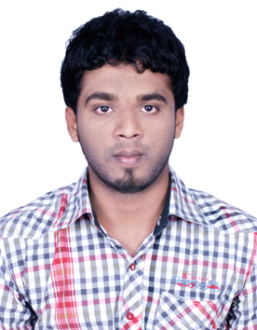

Mohamed
Cell : Whatsapp +971504753686 / +919979971283
E-mail : mohamed.376049@2freemail.com

OBJECTIVES:- To work towards achieving the greater success in my career through smart work, consistency and the ability to work with others to achieve organizational goals, aims and objectives.

SKILLS:
INTERPERSONAL SKILLS:- •Flexibility •Interactive •Good communicator •Patience •Punctuality
•Problem Solving •Product development • Quality assurance.
•Work closely with other developers and professionals.
•Organize and manage multiple priorities simultaneously.
•Quickly fit into any existing team of developers.
•Work through a project life cycle.
•Assist in planning the new site development.

TECHNICAL SKILLS:-
•Networking Engineering (CCNA) •HTML •C-programming •C++ •Presentation •Project management •Microsoft Office Applications (Word, Excel, PowerPoint, Outlook) •Photoshop cs6.

EXPERIENCE:- Blaster Waves IT Solution FROM June 2013 - TO Feb 2017

ROLE: Web Admin, Data Entry, Internet Marketing.

BCA SUMMARY :-

Title: Management Information System (MIS):-

- Project Description: The proposed system “MANAGEMENT INFORMATION SYSTEM” automates the employee management details and maintains separate database to maintain the employee details.
- Mini Project : Stock Management System in PHP.

WORK DESCRIPTION:-

- Design and develop sites and email marketing asset.
- Maintaining the existing websites.
- Build customized websites to the highest specifications.
- Editing, view and delete in Database management.
- Creating and Designing a new websites.
- Modification and troubleshooting in existing websites.
- Web development using dream viewer tool.
- Generating codes using HTML Tags.
- Generating outputs designing for CSS.
- PHP code may also be executed with a command-line interface (CLI) and can be used to implement standalone graphical applications.
- Generate dynamic page content using PHP.
- Create, open, read, write, delete, and close files on the server.
- Collect form data in PHP.
- Send and receive cookies in PHP.

COURSE COMPLETION CERTIFICATE :

- Network Engineering (CCNA)

EDUCATION:-

2013 – 2016 : B.C.A

Percentage : 52%
University : Alagappa University

2011 : HSC
Percentage : 59%
Institution : ST. Mary’s Hr. Sec School

2008 : SSLC
Percentage : 64%
Institution : M.E.S High School

PERSONAL DETAIL:-
- Date of birth : 16/03/1992.
- Nationality : Indian.
- Marital status : single.
- Language known : English, Tamil.

DECLARATION:-
I hear by declare that all the above Information is true to the best of my knowledge and belief.

Yours Truly

[MOHAMED]

