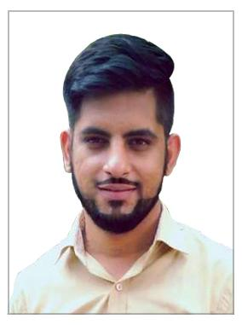
Karan
Communication: Whatsapp +971504753686 / +919979971283
Email: karan.376058@2freemail.com
Present Address : Dubai

- Me & My Objective :

More Than 4 Years ‘successful Experience In Sales, Customer Service’ And Support With Recognized Strengths In Problem – Solving And Planning/Implementing Proactive Procedures And Systems To Avoid Problems In The First Place. I believe I am an excellent at handling Multiple tasks at once, have inherit Conflict Resolution Skills, turned out to be a great team Player, self motivated and Adaptive by Nature Towards Learning New Things in Life.
- Work Experiences:

- Worked as an "Sales Executive" with One of India’s Reputed & Reliable Automotive Advising Firm “BCUBE IT SERVICES PVT LTD. , a firm deals in advising their existing & new clients about upcoming Car model, maintenance, mileage, Car workshops , My profile includes to serve and handle clients in order to give , proper knowledge about latest available fleet in Market & comparison between two brands at Udyog Vihar, Gurgaon (India).
Key Result Areas of Work:

- Make Call to the customer and provide all the description of their searching car.
- Handling the customer queries and giving correct direction.
- We were having direct tie ups with Car dealers.
- Calls were being made to the customers who have shown interest in purchasing the car.
- After Verifying the basic details and checking the intent of buying the car leads were passed to the respective car dealers.
- Leads were called through LMS (Lead Management System).

- Work Experiences:

- Worked as an "Advisor" with A Reliable & Prestigious Venture “SERCO INTERNATIONAL PVT. LTD. , a Reputed Multinational firm deals in multiple International processes and channelize the worldwide client’s business through the Excellent Business expertise, at Cyber City ,DLF City Phase III , Gurgaon (India). My profile includes to handle client queries, and to give them beneficial knowledge about multiple disorders of human body. (“Snoring Disorder” :-It’s Impacts & disadvantages).
Key Result Areas of Work:

- APRIA healthcare US Process.
- APRIA is focused on providing top quality services to our patients.
- Our ongoing self-monitoring and evaluation process ensures continual improvement in the homecare experience.
- From order accuracy to helpful customer service, timely delivery, patient education and equipment instruction.
- APIRA is committed to serving with excellence.

- Work Experiences:

- Worked as an "Advisor" with A Reliable & Prestigious Venture "FIS GLOBAL BUSINESS SOLUTIONS" PVT. LTD."US Telecom Process 02" a Reputed firm deals in multiple International processes and channelize the worldwide client’s business through the Excellent Business expertise , at Sector 18, on National Highway No. 8 , Gurgaon (India).
Key Result Areas of Work:

- Resolved all kinds client enquiries, mails lookup, mail & chats monitoring & reverts to international client queries.
- Handling all kinds of client hassles, queries & complaints, to give them product knowledge.
- Worked in close coordination with a huge team of 180 process members.
- Transforming feedbacks and escalate those to my seniors for quality variation.

- Academics Qualification:

Senior Secondary
Passed from Hrayana Board of School Education, Haryana, India

Secondary (Matriculation)
Passed from Hrayana Board of School Education, Haryana, India

- Technical Qualification:
Basic Level Computers Knowledge with MS Office.

- Personal Profile:

Date of Birth : 14th June 1994
Gender : Male
Marital Status : Single
Hobbies : Reading inspirational Bio's, Travelling & Listening Music
Permanent Address : Sirsa India
Visa Status : Visit Visa

Place:
Date: (KARAN)

