**Shiref**

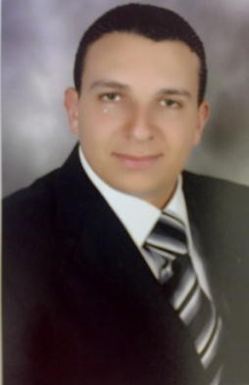

Alexandria-Egypt

Dammam, Saudi Arabia:I Live in

[shiref.376080@2freemail.com](mailto:shiref.376080@2freemail.com)

***MOB. NO***. Whatsapp +971504753686 / +919979971283

Personal Information:-

**Date of Birth :** 16/7/1982

**Nationality :** Egyptian

**Marital Status :** Married

* Skills***:-***

**MS OFFICE **

**AutoCAD **

**SAP** 

* Language

**Arabic **

**English **

* Previous Experience:-
  + - **From 25/3/2015 Till Now royal commission(RC) and Saudi electricity company(SEC) in Ras Alkhair as civil work engineer.**
  + **Switch Station 33KV.**
  + **Total coast 77million riyals Saudi.**
    - **From 2/3/2014 to 22/01/2015 royal commission (RC) in Jubail as civil work engineer.**
  + **MAINTNANCE CONTRACT.**
  + **Total coast 46 million riyals Saudi.**
    - **From 1/9/2012 to 1/03/2014 royal commission (RC) in Jubail as work control super visor.**
  + **REHABILITATION OF PUBLIC FACILITIES.**
  + **Total coast 60 million riyals Saudi.**
  + **From 4/3/2011 to 30/8/2012 in Alhassa Saudi electricity company(SEC) as project engineer**.
* **Administrative building consists of ground floor+ first floor**
* **Area 1350 m².**

###### From 1/8/2009 to 1/3/2011 in Sama project as site engineer.

* + **Building consists of ground floor +8 floors.**
  + **Area 4000 m².**
    - **From 1/7/2006 to 30/3/2007 Police Building In Smoha Garden as site engineer**.
* **Administrative building consists of abasement(garage) + ground floor +12 floor**
* **Area 7000 m².**
* Academic Education and certificates:-
* **2006 [Alex University ــ Civil Engineering]**
* **Graduation Grade :** Pass
* **Graduation Projects:**

Foundation Work For Design bridges**.**

Foundation Work for Design Port marine.

* **Project Grade :** good by ration (73 %).