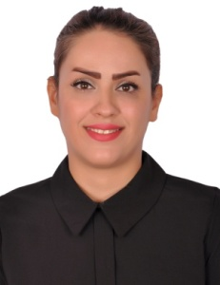
Maryam
E-mail: maryam.376082@2freemail.com
Mobile: Whatsapp +971504753686 / +919979971283
Career Objectives

To achieve project goal in a more timely and proficient manner of having the ability to work a driven initiating within the given guidelines and direction, and the ability to give the best and most proficient performance on the given task and to have international cultural exposure and hands-on experience in the field of hospitality management as a gateway to meaningful hospitality career.
Career summary

2012-2014
■Temporary promoter in some famous brands: cosmetic, perfume, sun glasses
2009-2012
■ English teacher in public schools and institutes.
2007-2009
■ Team and club translator in Zobahan Cultural and Sport club.
Skills
LANGUAGE SPOKEN
• Proficient English, Persian, Azeri Turkish
• Proficient in oral and written communication in English and Persian
SOCIAL SKILLS AND COMPETENCES
• Able to communicate with other people well with a motivation to maintain customer satisfaction.
ORGANIZATIONAL SKILLS AND COMPETENCES
• Energetic and reliable to associate and able to perform tasks well .Can work in diverse and logistical service environment, personable and a solid team player with great positive attitude.
Education
•BA in English translation to Persian
Personal Details
Date of birth: 10/06/1981

