CURRICULUM VITAE
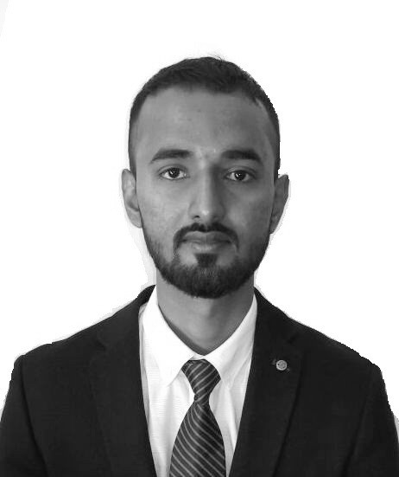
Mohammad
Electrical Engineer

Abu Dhabi- UAE
Mobile: +971504753686 / +919979971283
E-mail:
Mohammad.376100@2freemail.com

Objective:

To work and grow in an industry wherein I can utilize my extensive range of skills and abilities with a suitably challenging role to achieve further professional development by being resourceful, innovative and flexible.
Electrical Engineer (Relay, C.T, P.T, L.T panel, H.T panel, Electrical panels, common panel, DG meter board panel, Distribution box.
Total Experience: -1Years & -5months
Being an Electrical Engineer, I am well aware of Electrical Equipment’s like circuit breaker, Relay, C.T, P.T and transmission line, all Electrical distribution system which will help in executing the work to the perfection.
Educational qualification:
Bachelor’s Degree in Electrical Engineering from M A K A University, WB, INDIA with 70.04% or 7.04 CGPA Grade.
Training Certification:
Undergone 21 days of vocational training at MEJIA THERMAL POWER STATION (DAMODAR VALLEY CORPORATION ) at Bankura- 722183, Capacity – 2340 MW, Kolkata (W.B).
Computer Skills:
Ms-Office (Word,Excel, PowerPoint), AutoCAD.
Experience:
Electrical Engineer and MEP Coordinator Aug 2016 - Dec 2017 (1Yrs. 5months) Taneja Vidyut Control Pvt. Ltd – New Delhi

Page 1 Mohammad– Electrical Engineer
Professional Projects:

- Uniworld City, Kolkata
- Kolkata West International City, Kolkata
- M3M India, NCR Delhi

Job Responsibilities:
- Monitoring on going Electrical site activity and ensuring that all the activity shall be carrying without violation of standard, procedure and specification.
- Inspect electrical systems, equipment, and components to identify hazards, defects, and the need for adjustment or repair, and to ensure compliance with codes.
- Follow AutoCAD drawing to determine the location of wiring equipment’s like slab conducting, wall conducting, box fixing, distribution box, lighting, smoke detector, MCP & hooter and cable tray laying and to ensure conformance to building and safety tools.
- Successfully Erection & Commissioning of MCP, Hooter, Smoke Detector, Heat Detector, Fire panel.
- Successfully Erection & commissioning of LT & HT cables under Trench and over Cable Tray.
- Follow single line diagram to make demands for Electrical equipment’s like MCB, Cables, Cable tray etc.
- Successfully Erection of Electrical panels, common panels, DG meter board, LT panel, HT panel & DGLT panel.
- Provide preliminary sketch and cost estimates for material and services.
- Preparation of daily, weekly and monthly progress reports.
- Prepared Billing according to bill of quantity and knowledge of Escalation bill.
- Prepared Estimation and Costing of Materials.
Strengths:
- Good logical and analytical approach
- Hardworking, sincere and honest
- Optimistic & a quick learner
- Confident and pleasing personality
- Good decision making skills

Personal Profile:
Name | : | Mohammad
Date of birth | : | 11th May' 1992
Nationality | : | Indian
Marital status | : | Single
Visa Status | : | Visit Visa (Expiring on 21st March' 2018)
Availability  Page 2 | : | Immediate  Mohammad -Electrical Engineer
Declaration:
I hereby declare that the above furnished information is true to the best of my knowledge.
Date: 10.01.2018  Place: Abu Dhabi | Yours Sincerely  Mohammad
Page 3 | Mohammad -Electrical Engineer

