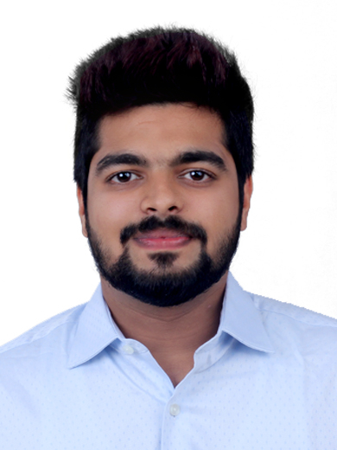
Wilno
Satwa, Dubai
E-mail: wilno.376135@2freemail.com

Objective
To attain a challenging position in a stimulating and growth oriented environment enabling me to add value to the organization through a blend of experience and education, and enrich my skills and knowledge.

Work Experience
SustanGrow Business Solutions, Kochi, India Jan 2017-July 2017
Business Development Executive
- Generated business leads and follow up on sales opportunities.
- Acquired new clients by cold calling & social media.
- Scheduled appointments and create customized proposals to generate new business.
- Cold calling potential customers and building relationships.
- Worked closely with other teams to develop new business.
- Researched the market and identified potential target customers.

Transferet Relocations, Bangalore, India Aug 2016-Jan 2017
Operations Supervisor
- Ensure the quality of the product and service is maintained at the highest possible standards for the customer.
- Ensure that all parties are working together to guarantee that shipments are packed, sent and delivered in a timely manner.
- Supervise the transportation of products from one location to another.

Academic Qualifications
Speedwings Aviation Academy 2015-2016
- PG Diploma in Logistics-Supply Chain and Transport Modes

St.Berchmans college (India) 2012-2015
- Bachelors of Computer Applications (BCA)

Metropolitian higher secondary school (India) 2009-2011
- Higher secondary school certificate (12th Grade)

Metropolitian higher secondary school (India) 2008-2009
- Secondary school certificate (10th Grade)

Skills

Technical Windows, MS Office- Word, Excel, PowerPoint

Personal Communication and social skill, Negotiation and Convincing skill

Personal Merits
- Certified in IATA DGR(Dangerous Goods And Regulations) – Category 3
- Desire to learn, develop and adjust to professional requirement and responsibilities.
- Dedicated and hard working.
- Extrovert, outgoing and friendly.
- Languages known : English, Malayalam, Hindi, Tamil

Personal Information
- D.O.B : 23/07/1993
- Age : 24
- Gender : Male
- Marital Status : Single
- Visa Status : Visit
- Nationality : Indian

