NAME: Syeda
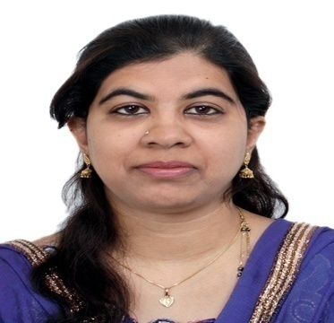 | Mobile No Whatsapp +971504753686 / +919979971283  E-Mail : syeda.3796190@2freemail.com

EDUCATIONAL qUALIFICATION: b.COM (bANGALORE UNIVERSITY)
aDIITIONAL QUAIFICATION : MBA (persuing)
SPECIALISATION : FINANCE AND Accounts

UAE experience:

Accountant:

Al Meshrakh Timber Trading LLC, Dubai, UAE
- Assistant Finance Manager: Vat returns filling / Brs/ A/r & A/p, maintaining petty cash book, Invoice making, Monthly reporting, Forwarding debit notes to the principals for Purchase Rebates/Shortages, Finalising Balance Sheet, Hr etc

Rainbow Plastic Industries LLC, UAQ, UAE. – 2 years
- Drafting lc, Invoice Discounting, Cheque Disconting, Follow up for the due dates and interest for o/d, Handling Petty cash, Working on Tally Erp9, Followup for import documents, giving salaries, administration etc.

Paramount Middle East Trading Company.

- General Accounts: Posting of entries, A/r& A/p, maintaining petty cash book, Raising bills. Forwarding debit notes to the principals for Purchase Rebates/Shortages etc

- Warehouse Administration – Independent handling of routine Warehouse Administration and Management in a busy atmosphere and reporting to Proprietor. Processing GRA with Purchase Cost of Shipment and updating local & Import purchase Import shipments. Invoicing of Project & Retail jobs, preparing project cost and reporting the same to the management.

M.k.Ahmed Super Mart

- General Accounts – Posting of Journal Vouchers, Bank & Cash payment vouchers. Monthly Bank reconciliation statements which covered almost 6 bank accounts A/r and A/p, Maintaining petty cash book. Overlooking and guiding the assistants in the daily routine accounting. After the close scrutiny of the accounts and the closing of the books of accounts I do the finalizing of the balance sheet with the confirmation of the vendors. Compilation of group accounts and Business unit wise profitability statement analysis and reporting to Proprietor.

- Pay Roll – Monthly processing of Pay roll through Real Soft and generation of WPS files. Uploading the files through WPS System to the bank for payment of salaries on due date.

- Additional Jobs – Maintaining all files relating to the company like Memorandum of Association, Power of Attorney, Contracts with Principals/Suppliers, Trade Licenses and their timely renewal.

Professional profile

Company/Firm | Country | Designation |  | Period
Al Meshrakh Timber Trading LLC | Dubai, UAE | Accountant |  | Jan 2016 to till date
Rainbow Plastic Industries LLC | UAE, UAQ | Accountant |  | Dec2013 to Dec 2015
M.K.Ahmed Super Mart | India, Bangalore | Accountant cum Hr |  | Sept 2001 to Oct 2005
Paramount Middle East Trading Company | India, Bangalore |  | India, Bangalore | Mar 2006 to Nov 2013

 | UNIVERSITY
S.S.L.C | Bangalore University
P.U.C | Bangalore University
B.COM | Bangalore University

IT/ERP EXPOSURE
- Worked in Tally ERP 9
- Worked in Microsoft Office Tools.

STRENGTHS/GROWTHS/ACHIEVEMENTS
- Ability to work under pressure in fast-paced, time-sensitive, challenging environments.
- Strong planning, coordinating and problem solving abilities.
- Willingness to interact with and work in a team.
- Strong accounting and system knowledge.
- Capability and capacity to scrutinize records and supervise others.

Personal details
- Sex : Female

- Nationality : Indian
- Marital Status : Married
- Languages known : English, Hindi, Kannada, Malayalam and Tamil

other specificationS

interests

- Collecting currencies of different countries.
- Photography.

