CURRICULAM VITAE 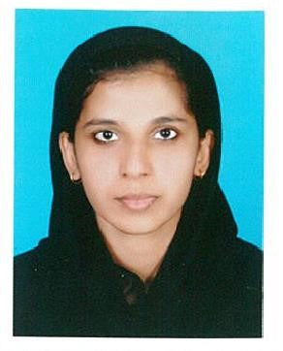

SHARMINAS

Mobile: Whatsapp +971504753686 / +919979971283
E-mail: sharminas.376198@2freemail.com

Career Objective

To work in an organization that would offer me the necessary platform to make maximum use my talents within aim of achieving personal as well as organization growth.

Application for the post of

- Back office work
- Lab attendant
- Receptionist/customer service
- IT Employee
- Data Entry Worker
- Punching and coding
- Computer teacher

Personal Qualities

- Good at communication skill
- Perform various duties as assigned
- Quick learner
- Multi task management
- Smart work

Languages Known

English, Hindi and Malayalam

Educational Qualification

Course | Name of  School/College | Board/University | Percentage | Year
MSc  Computer  Science | Annamalai University | Annamalai University | 70% | 2016
BSc  Computer  Science | MIC Arts Science College | Kannur University | 69% | 2014
HSC | Iqbal HSS | State Board | 68% | 2010
SSLC | Durga HSS | State Board | 81% | 2008

Additional Qualification

• Computer Operator and Programming Assistant (National Trade Certificate issued by government of India)

TECHNICAL SKILLS

Operating System
- Windows 2000
- Windows XP
- Microsoft Word, Excel
Languages
- C,C++,c#
- Basic of java
- VB.NET

Data bases
- SQL
- MY SQL
- Designing of Data base

Web Technologies

- HTML

Personal Details

Name : Sharminas
Visa status : Husband Visa
Date of birth : 15/03/1992
Nationality : Indian
Sex : Female
Marital Status : Married
Religion : Muslim

Declaration

I hereby declare that the statements made in the above resume are true and correct to the best of my knowledge and belief.

Reference

Up on Request.

SHARMINAS

